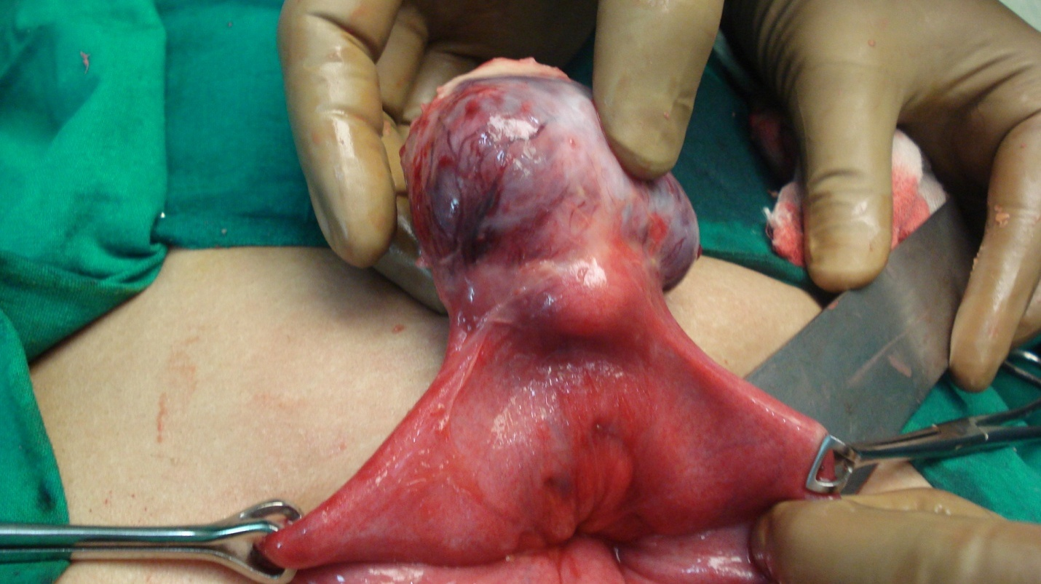 Figure Intra operative photograph showing tumor arising from jejunum

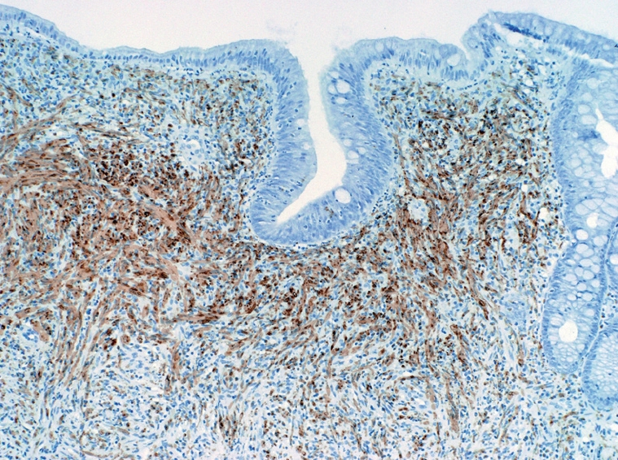 Figure 2 Immunohistochemistry showing strong s-100 reaction