Photo 1
PCR product (from left to right: lane 1-4 negative samples, lane 5 positive sample 26 (320bp), lane 6 DNA Leishmania ladder- 1kb).
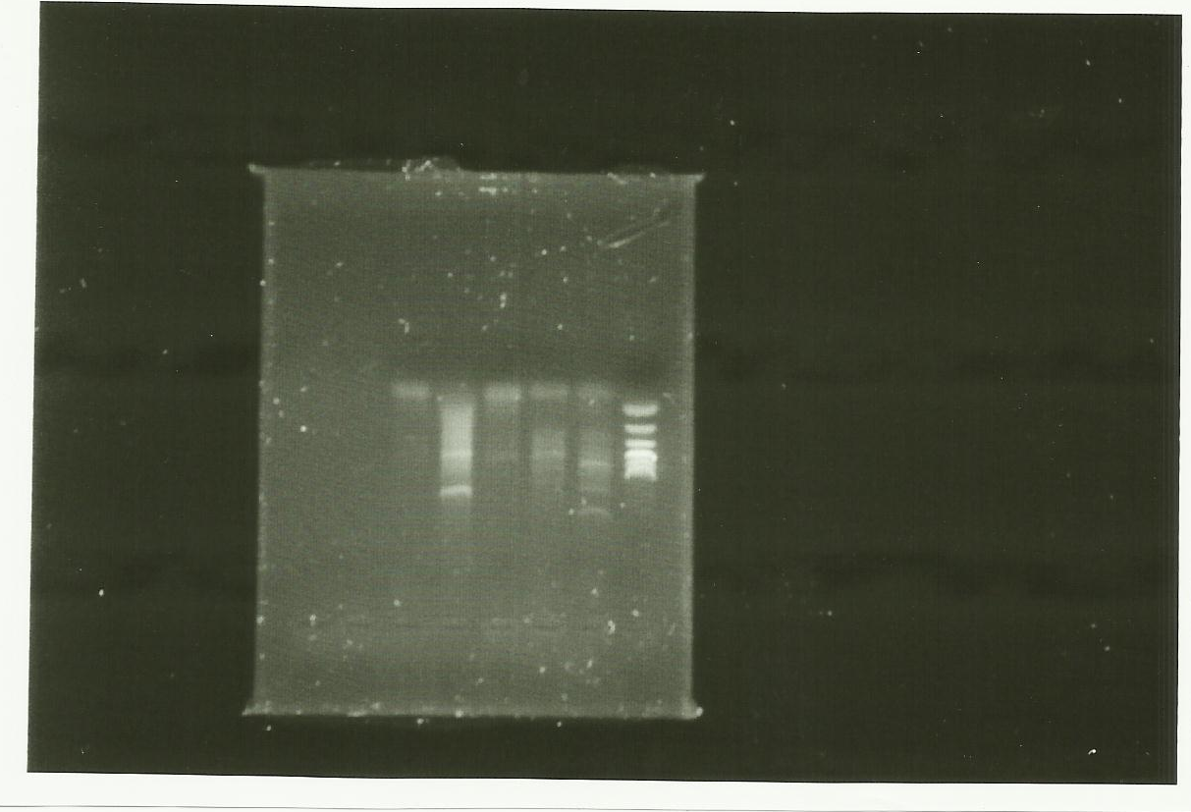
Left L1 L2 L3 L4 L5 1Kb Right
L: lane

Fig 1. The total genome sequence of the positive sample (26).

1 :
* 20 * 40
tttactgttattgctagtgttagctgttgtattggactgtaccgacc
TTTACTGTTATTGCTAGTGTTAGCTGTTGTATTGGACTGTACCGACC: 47
1 :
* 60 * 80 *
cgccccctttgacgcccttgatgttctccttctttagtttagcatcg
CGCCCCCTTTGACGCCCTTGATGTTCTCCTTCTTTAGTTTAGCATCG: 94
1 :
100 * 120 * 140
agcccgctttacgcccagccagcaaggcccatgtttagccctgccac
AGCCCGCTTTACGCCCAGCCAGCAAGGCCCATGTTTAGCCCTGCCAC: 141
1 :
* 160 * 180
tttactgttgtcaccaagttcagggaccagatgtactggccgctaag
TTTACTGTTGTCACCAAGTTCAGGGACCAGATGTACTGGCCGCTAAG: 188
1 :
* 200 * 220 *
gggcgcataagccccgttcctactctgggccttgttcgtggacaggc
GGGCGCATAAGCCCCGTTCCTACTCTGGGCCTTGTTCGTGGACAGGC: 235
1 :
240 * 260 * 280
ggttgatgcctaacctcaacaccgttcataattcgtatggggggaac
GGTTGATGCCTAACCTCAACACCGTTCATAATTCGTATGGGGGGAAC: 282
1 :
* 300 * 320
gcaactatagaatttaaaattagggggaccaaatgttcccctgatcg
GCAACTATAGAATTTAAAATTAGGGGGACCAAATGTTCCCCTGATCG: 329
1 :
* 340 * 360 *
gacagaccgcacggcgcaaacttatcctacccggcatttagggggcg
GACAGACCGCACGGCGCAAACTTATCCTACCCGGCATTTAGGGGGCG: 376
1 :
380 * 400 * 420
gtgggggcatcaattggtcagcggaatgctgaaaaggactgcgggca
GTGGGGGCATCAATTGGTCAGCGGAATGCTGAAAAGGACTGCGGGCA: 423
1 :
* 440 * 460 *
cttgcataacaggtagaggtcagatgtgtgggaggaggaatttagtg
CTTGCATAACAGGTAGAGGTCAGATGTGTGGGAGGAGGAATTTAGTG: 470
1 :
480
taggaa----------
TAGGAA: 476
1

