**AUTHORSHIP AND CONSENT FORM**

# To, TheEditor-In-Chief, BJMS Sub: Submission of Manuscript entitled, “SUBUNGUAL MALIGNANT MELANOMA: Difficulty in Early Diagnosis.” for publication as a “Case report”  DearSir,

# Please find enclosed manuscript entitled, “SUBUNGUAL MALIGNANT MELANOMA: Difficulty in Early Diagnosis.” for publication as a “Casereport” in your esteemed journal.

“This manuscript is an unpublished work which is not under consideration elsewhere and the results contained in this paper have not been published previously in whole or part, except in abstract form. In consideration of the BJMS accepting my/our submission for publication, the author(s) undersigned hereby assign all copyrights ownership to the BJMS and shall have no right to withdraw its publication. It is expressly certified that I/we, have done/actively participated in this study and agree to the accuracy of contents of this manuscript. It was conducted in accordance with current ethical considerations and meets with the committee’s approval. I/all of us agree to its publication in BJMS and to the authorship as expressed in this declaration and in the title page of our manuscript***”***.

Sincerely yours, DATE 06-01-2013

Shah Naveed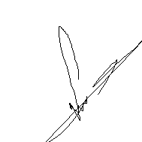

Hasina Quari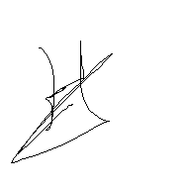

Gurpreet Singh 