TABLES
Table 1: CLSI screening criteria for ESBL detection
Antibiotics | Zone diameters
Cetazidime (30µg) | ≤ 22mm zone
Cefotaxime(30µg) | ≤ 27mm zone
Ceftriaxone (30µg) | ≤ 25mm zone
Cefopodoxime (10µg) | ≤ 17mm zone
Aztreonam (10µg) | ≤ 27mm zone

Table 2: Combined disk test (ESBL + Amp C)
 |  | Cefotaxime  CTX30 | Cefotaxime+Clavulanate  CTX+C | Cefotaxime+Cloxacillin  CTXCX
ESBL | CTX+C | ≥ 5 mm | - | -
ESBL | CTXCC | - | < 4 mm | ≥ 5 mm
Amp C | CTXCX | ≥ 5 mm | - | -
Amp C | CTXCC | - | ≥ 5 mm | < 4 mm
ESBL+Amp C | CTX+C | < 4 mm | - | -
ESBL+Amp C | CTXCC | - | ≥ 5 mm | ≥ 5 mm
CTX-Cefotaxime, CTX+C-Cefotaxime+Clavulanic acid, CTXCX- Cefotaxime+Cloxacillin, CTXCC- Cefotaxime+Clavulanic acid+Cloxacillin.
Table 3: ESBL distribution in wards
Ward | No of isolates | ESBL Producers | Percentage (%)
Medical | 47 | 23 | 48.93
Surgical | 73 | 32 | 43.83
ICU | 50 | 37 | 74
Transplant Centre | 19 | 15 | 78.94
Burn Center | 11 | 7 | 63.63
Total | 200 | 114 | 54

Table 4: Distribution of isolates
Microorganism | No of isolates screened | ESBL producing organism | Suspected AmpC producers | Confirmed AmpC producers
E. coli | 129 | 77 | 31 | 28
Klebsiella | 67 | 37 | 28 | 26
Proteus | 4 | 0 | 2 | 1
Total | 200 | 114 | 61 | 55

Table 5: Comparative analysis of various tests for ESBL production
 | Screen positive | E-Test | PCDT | DDST | Confirmed ESBL
Isolates | 131 | 112 | 109 | 92 | 114
Percentage | 65.5% | 56% | 54.5% | 46% | 57%

FIGURES
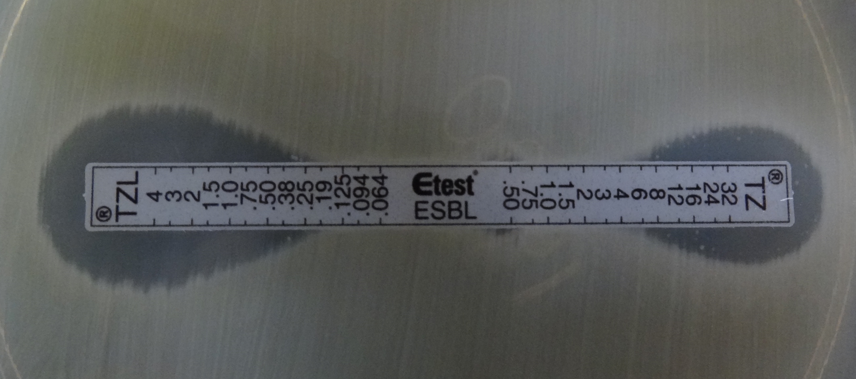
Figure 1: E-Test with ceftazidime (TZ)/ceftazidime clavulanic acid (TZL) strip showing MIC of TZ/TZL ≥ 8 in an ESBL isolate along with a small “Phantom zone”.

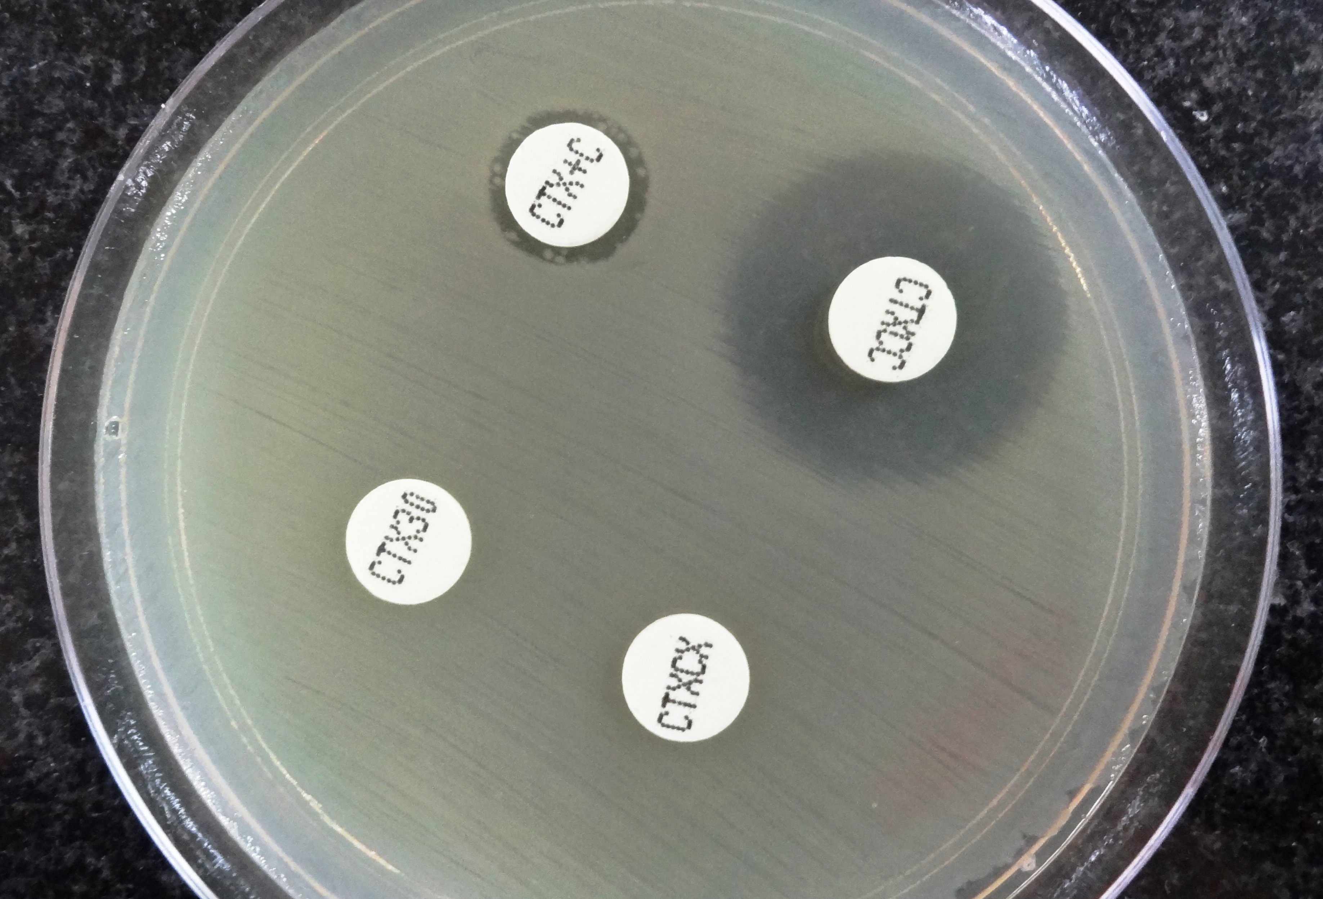
Figure 2: Organism showing enhanced zone of sensitivity (≥5mm) with ceftazidime/ clavulanate/cloxacillin disk as compared to ceftazidime/clavulanate disk and ceftazime cloxacillin disk on Combined disk test showing ESBL and Amp C production respectively

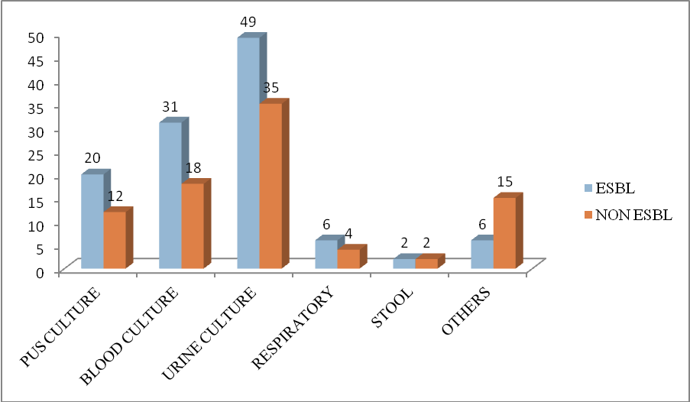
Figure 3: Relative frequency of ESBLs and Non ESBLs from various specimens

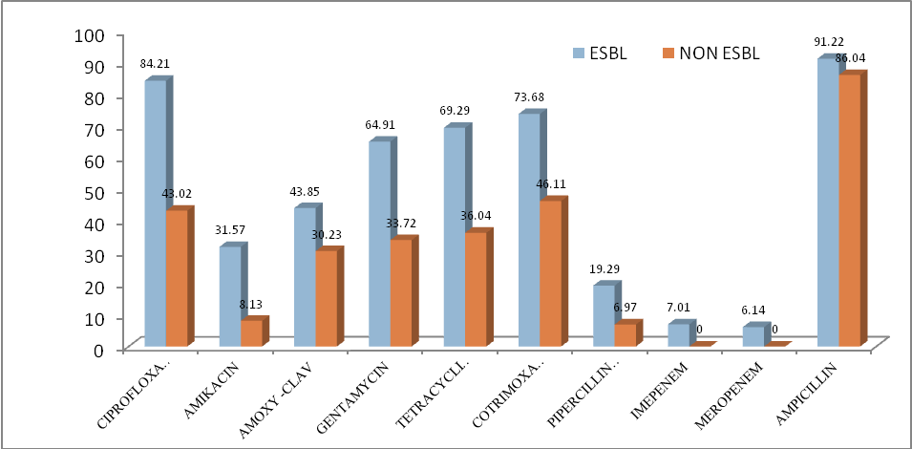
Resistance expressed in %age
Figure 4: Comparative resistance among ESBL and Non ESBL isolates

