Fig.1: Weight of Animals Administered with Monosodium Glutamate

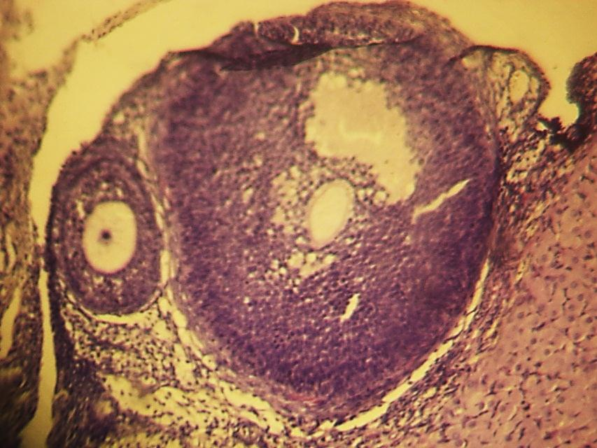
O
FA
O
ZP
ZG
ZG

TI
TE

Fig.2: Control. X100
Normal histology of the ovary, O = Oocyte, ZP = Zonal pellucida, ZG = Zonal granulosa, FA = Follicular antrum, TI = Theca interna, TE = Theca Externa

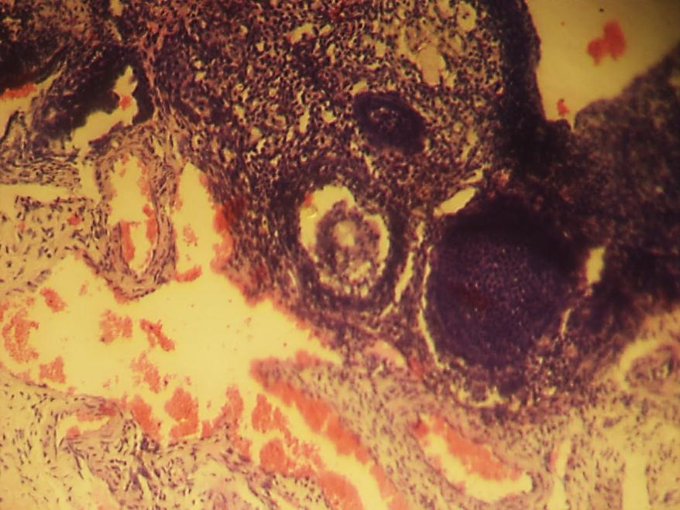

Fig. 3: (Group A, 0.10g/kg MSG) X100
Infiltration of inflammatory cells in and around the oocyte as well as in the zonal granulosa layer (Red rings)
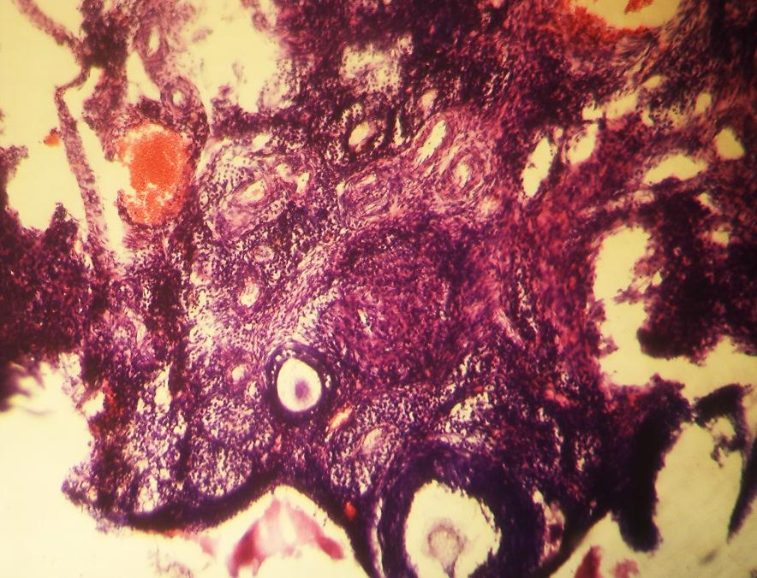

Fig. 4: (Group B, 0.15g/kg MSG) X100
Severe infiltration of inflammatory cells around the oocyte on the zonal granulosa layer (ZG), as well as in the theca layer (Red rings). There is distortion of tissue architecture.
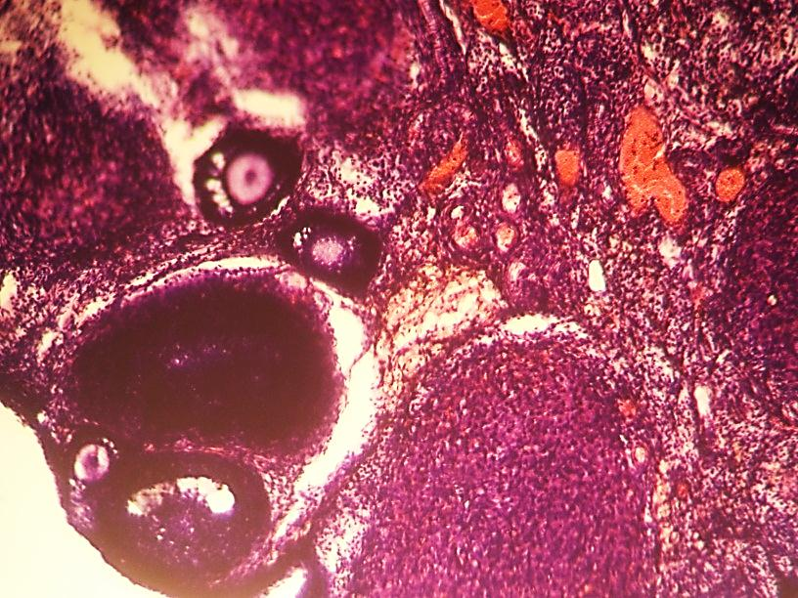

Fig. 5: (Group C, 0.20g/kg MSG) X100
Severe infiltration of inflammatory cells around the oocyte on the zonal granulosa layer (ZG)

