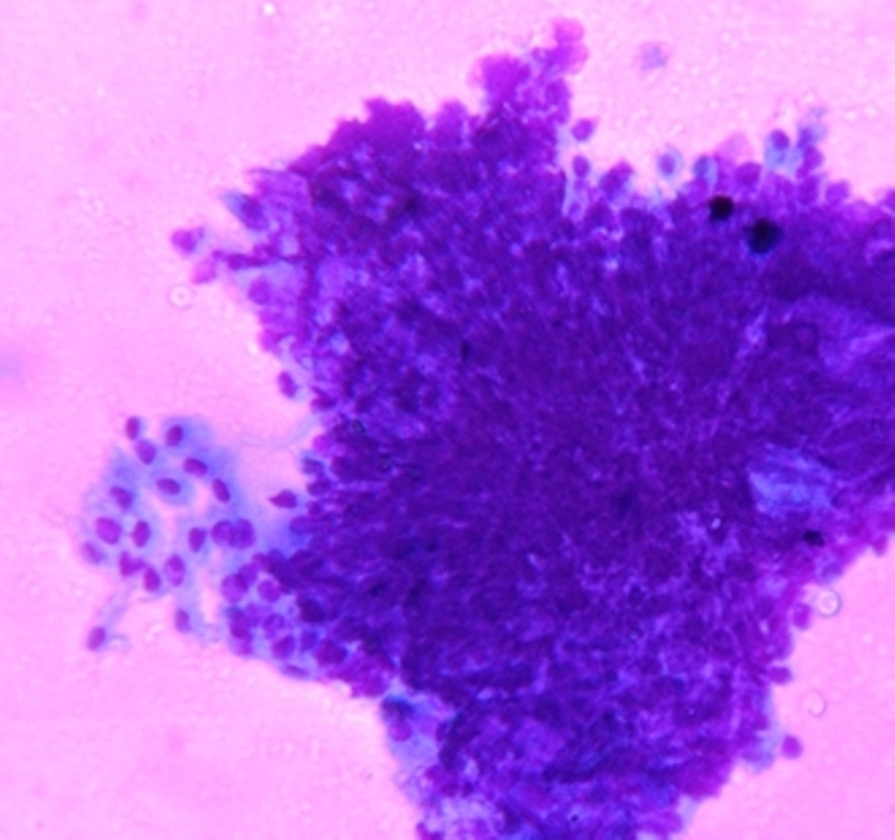

Fig. 1 : Photomicrograph showing cytological aspirates from Papillary mucinous cyst adenocarcinoma of ovary (400x Leishman-Giemsa stain)

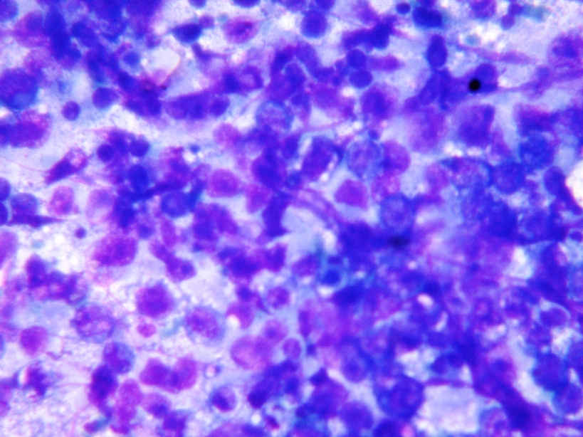

Fig. 2 : Photomicrograph showing cytological aspirates from Dysgerminoma of ovary (400x Leishman-Giemsa stain)

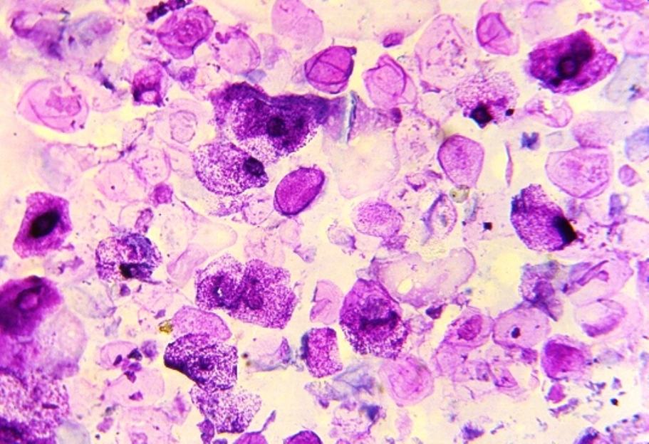

Fig. 3 : Photomicrograph showing cytological aspirates from Benign cystic teratoma of ovary (400x Leishman-Giemsa stain)