Date : 23th May 2014

Editor-in-Chief Bangladesh Journal of Medical Science
Ibn Sina Trust
1/1-B, Kallyanpur, Mirpur, Dhaka-1216
BANGLADESH

Dear Editor,

SUBMISSION OF MANUSCRPT

We are pleased to enclose a full-length original article entitled “Repeatability of Universiti Teknologi MARA reading chart” for publication consideration in Bangladesh Journal of Medical Science.

It is a medical sciences type of manuscript. In this manuscript we showed that the Malay related words and Malay unrelated words reading chart provide good consistency and good agreement in repeated measurements of the reading rate among young adults in routine optometric and ophthalmology near vision assessment.

This study was performed and taken into consideration about the ethical responsibilities and have been approved by the ethical review committee of the university. The Exploratory Research Grant Scheme (ERGS) awarded by The Malaysia Ministry of Education funded this study.

All listed authors were sufficiently contributed on this work as in research idea, data collection, data analysis and paper writing to grant in publication authorship. The following is the list of authors for this article.
AUTHOR’S NAME: NOOR HALILAH BUARI¹²³
NUR HIDAYAH YUSOF³
ADIB MOHD-SATALI³
AI-HONG CHEN¹²³

AFFILIATION & ADDRESS: ¹Community of Research HW, Research Management Institute, Universiti Teknologi MARA 40450 Shah Alam, Selangor, Malaysia.

²Optometry And Visual Sciences Research Center (iROViS), Universiti Teknologi MARA 40450 Shah Alam, Selangor, Malaysia

³Optometry department, Faculty of Health Sciences, Universiti Teknologi MARA, 42300 Bandar Puncak Alam, Selangor, Malaysia

Details of the corresponding author are as follows

Corresponding author : Prof. Dr. Ai-Hong Chen
Postal Address : Community of Research (HW), Research Management Institute, Universiti Teknologi MARA 40450 Shah Alam, Selangor, Malaysia.
Phone : +6012 3347032
Fax : +603 3258 4597
Email : aihong0707@yahoo.com

This manuscript is original and has not been published or under consideration for publication elsewhere. We have no conflicts of interest to disclose.

Thank you for your consideration.

Sincerely,

Ai Hong, Chen (PhD)
Professor of Optometry
Optometry program, Faculty of Health Sciences
Universiti Teknologi MARA
Bandar Puncak Alam, Selangor, MALAYSIA

Author undertaking:

Reference: Manuscript entitled: Repeatability of Universiti Teknologi MARA reading chart

Author(s): | NOOR HALILAH BUARI | 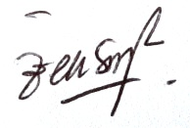
 | NUR HIDAYAH YUSOF | 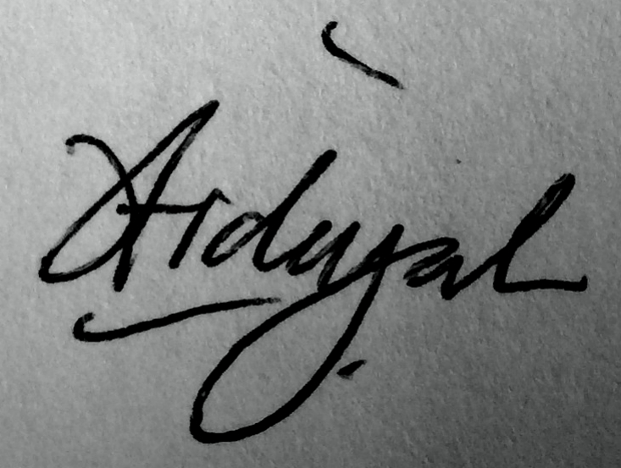
 | ADIB MOHD-SATALI | 
 | AI-HONG CHEN | 