Authors Undertaking
- Noor Suryani Mohd Ashari, principal investigator. 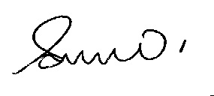
- Siti Noor Syuhada Mohd Amin, co-reseacher, patient and subject collection. 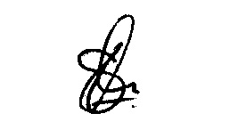
- Wan Zuraida Wan Abdul Hamid, co-reseacher, sample analysis. 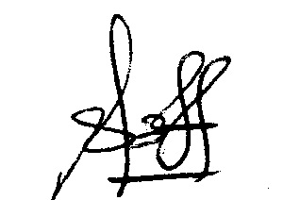
- Azriani Abdul Rahman, , co-reseacher, data analysis. 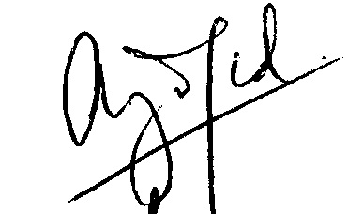
- Irfan Muhammad, co-reseacher, history taking and assessment of the patient. 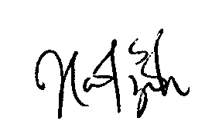
Reference: Manuscript entitled: Determination of Interleukin 31 (IL-31) serum levels according to severity of allergic rhinitis
Running title: IL-31 in allergic rhinitis
Author(s)
- Noor Suryani Mohd Ashari, Department of Immunology, School of Medical Sciences, Universiti Sains Malaysia, Kelantan, Malaysia.
- Siti Noor Syuhada Mohd Amin, Department of Immunology, School of Medical Sciences, Universiti Sains Malaysia, Kelantan, Malaysia.
- Wan Zuraida Wan Abdul Hamid, Department of Immunology, School of Medical Sciences, Universiti Sains Malaysia, Kelantan, Malaysia.
- Azriani Abdul Rahman, Department of Community Medicine, School of Medical Sciences, Universiti Sains Malaysia, Kelantan, Malaysia.
- Irfan Muhammad, Department of Otorhinolaryngology Head and Neck Surgery, School of Medical Sciences, Universiti Sains Malaysia, Kelantan, Malaysia.

Corresponding author: Dr Noor Suryani Mohd Ashari
Department of Immunology,
School of Medical Sciences,
Universiti Sains Malaysia,
16150 Kubang Kerian, Kelantan, Malaysia
Phone : +609-7676234
Email : suryani@usm.my

Submitted for publication in the journal:
BANGLADESH JOURNAL OF MEDICAL SCIENCE
Conditions of Submission:
Ownership Rights: All proprietary rights other than copyright (such as patient rights) are reserved to the authors, this include the right to reproduce original figures and tables from this item in their future works, provided full credit is given to the original publication.
Originality: The authors assures that this submission is an original work and that neither this work nor one with substantially similar content has been published elsewhere in whole or in part (except in abstract form), that it has only been submitted for this publication, and that it will not be submitted elsewhere pending written notice of acceptance or rejection by this journal (Please express explicitly if you have the plan to publish any more article based on partial data of this work).
Declaration of authorship: The undersigned certify that all authors have participated sufficiently in the conception and design of this work and the analysis of the data (when applicable), as well as the writing of the manuscript to take public responsibility for it. The undersigned believe the manuscript represents valid work and have reviewed the final version of the manuscript and approve it for publication.
Data availability: The undersigned attest that they shall produce the data upon which the manuscript is based for evaluation by the Editors of their assignees should it be requested.
Disclaimer: The undersigned assures that the manuscript contains no libelous or unlawful statements and does not infringe on the rights of others. If excerpts (text or artwork) from copyrighted works are included, written permission will be secured by the authors and proper credit will be shown in the manuscript.

