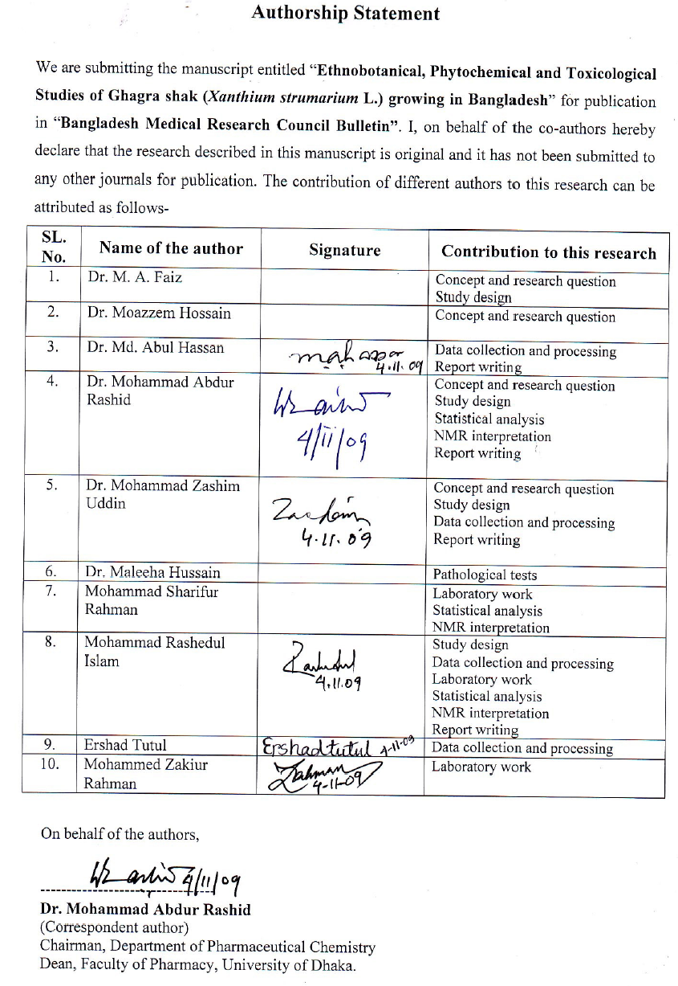

*We are trying to collect signature of all the co-authors. But it will take few more days. One of the co-authors is in Japan and another one is in Sylhet.

