Available Online

J. Sci. Res. **15** (3), 887-902 (2023)

**JOURNAL OF**

**SCIENTIFIC RESEARCH**

www.banglajol.info/index.php/JSR



**Publications**

Synthesis, Spectral and DFT Study and Molecular Docking Investigation of (*E*)-3-(3-Bromo-4-Methoxyphenyl)-1-(4-(Methylthio) Phenyl)Prop-2-en-1-one

R. Subha1, N. Ingarsal2[1]*

1Department of Chemistry, DG Govt. Arts College for Women (Affiliated to Bharathidasan University, Trichy), Mayiladuthurai, Tamilnadu, India

2Department of Chemistry, Rajah Serfoji Govt. College (Autonomous) (Affiliated to Bharathidasan University, Trichy), Thanjavore, Tamilnadu, India

Received 19 February 2023, accepted in final revised form 27 June 2023

Abstract

In this study, a new (*E*)-3-(3-bromo-4-methoxyphenyl)-1-(4-(methylthio)phenyl)prop-2-en-1-one was synthesized by a condensation method. It has been characterized using FT-IR, UV-Vis spectra, and NMR spectra. Furthermore, the title compound was subjected to DFT analysis to observe its molecular structure and vibrational wavenumbers using the B3LYP/6-311G(d,p) approach. The total energy distribution (TED) method was used for complete vibrational analysis. Proton and carbon nuclear magnetic resonance (NMR) chemical shifts of the target compound were calculated theoretically by the gauge independent atomic orbital (GIAO) method and compared with experimental data. For the title molecule, the geometrical parameters provided the best agreement with experimental ones. The HOMO-LUMO energy gap, chemical reactivity parameters, Mulliken atomic charge, and molecular electrostatic potential (MEP) are also studied. The results obtained from the DFT analysis were in good agreement with the experimental data. The synthesized compound was also used in molecular docking studies to understand its biological activity.

*Keywords*: Chalcone; DFT analysis; Molecular docking study.

© 2023 JSR Publications. ISSN: 2070-0237 (Print); 2070-0245 (Online). All rights reserved.

doi: <http://doi.org/10.3329/jsr.v15i3.64498> J. Sci. Res. **15** (3), 887-902 (2023)

1. Introduction

Chalcones are bicyclic open-chain flavonoids bonded by a carbonyl group and two α,β-unsaturated carbon atoms [1-3]. These are well-known intermediates for the synthesis of various heterocyclic compounds such as isoxazoline [4], pyrazole [5], pyrazole [6], pyridine [7], cyclohexenone [8] and oxadio Azole derivatives [9]. It is a synthetic intermediate and can compete with drugs. Chalcone derivatives are promising compounds because they absorb chromophores in the UV range of sunscreens. The nonlinear optical (NLO) properties of conjugated organic compounds are the subject of many calculations and experiments due to their wide implications in photonics and optoelectronics, integrated optics, photophysics, high-speed optical communication, therapy mesh count, and other storage analyses. . application prospects [10]. Chalcones have attracted attention due to their excellent nonlinear optical properties [11]. In addition, new drugs, chalcone analogs, are increasing nowadays due to their ability to inhibit activity, making them attractive to drug users for treating diseases with layers of the inflammatory process [12]. In general, chalcones have medicinal properties such as anti-inflammatory, antibacterial, antibacterial [13], anti-inflammatory, antibacterial [14], antibacterial antibiotics, antibiotics, and anti-inflammatory drugs [15]. ]. Chalcone phenolic groups' free radical scavenging property has increased the interest in consuming chalcone-containing plants. The cyclooxygenase (COX-2) isoenzyme produces PGs that cause pain, inflammation, and fever.

In addition to its ability to cause peripheral inflammation, COX-2 isozyme expression is elevated in many types of human cancers, including gastric, breast, lung, colon, esophageal, prostate, and hepatocellular carcinomas. [16]. With this in mind, molecular docking experiments were performed, and the results are presented in this paper. In this study, target elements were synthesized and compared with theoretical data using analytical methods such as FT-IR, NMR, and UV-Vis spectroscopy. We also investigate NLO, MEP, dipole moment, homomorphism, and Mulliken analyses. Additionally, docking analysis was performed to determine their biological applications.

**2. Experimental**

**2.1. *Instruments***

All chemicals were purchased from Sigma-Aldrich and E-Merck chemical companies for synthesis. The melting point was observed in open glass capillaries on the Mettle FP51 melting point apparatus and is uncorrected. The UV spectrum of the titled compound was recorded in SHIMADZU-1650 PC SPECTROMETER (λmax nm) using spectral-grade methanol. Infrared spectra (KBr, 4000-400 cm-1) were recorded on AVATAR-NICOLET 330 Fourier transform spectrophotometer. The BRUKER AV400 NMR spectrometer was used for recording 1H and 13C NMR spectra of chalcone synthesized, operating at 400 MHz, which was used for 1H NMR and 100 MHz for 13C NMR spectra in CDCl3 solvent using TMS as internal standard.

**2.2. *Synthesis of (E)-3-(3-bromo-4-methoxyphenyl)-1-(4-(methylthio)phenyl)prop-2-en-1-one***

A mixture of 3-bromo-4-methoxybenzaldehyde (0.01 mL) and 4'-methylthioacetophenone (0.01 mL) is taken in a 250 mL flask equipped with a magnetic stirrer. It was dissolved in an Erlenmeyer flask in 10 mL of rectifying spirit [17]. Then 10 mL of 20 % NaOH solution was added dropwise to the reaction mixture and stirred for 30 minutes until the solution became cloudy. Completion of the reaction was continuously monitored by TLC. After vigorous stirring for 4-5 hours, the reaction mixture was poured into cold water, filtered to obtain the crude compound, and recrystallized from ethanol. It melted at 128 °C and was a bright pale yellow color.

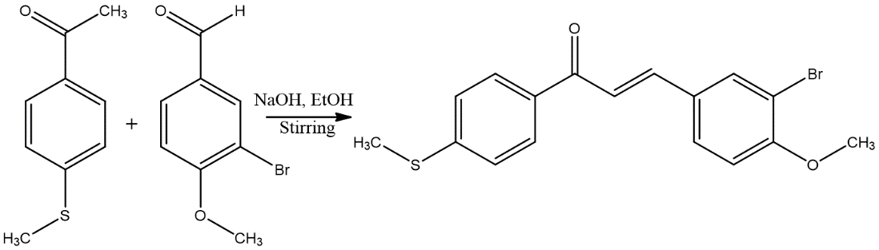

Scheme 1. Synthesis of (*E*)-3-(3-bromo-4-methoxyphenyl)-1-(4-(methylthio)phenyl)prop-2-en-1-one.

**2.3. *Computational details***

In the present study, the DFT calculations are made using Gaussian09W [18] program with the B3LYP/6-311G (d, p) basis set. The GaussView5.0 [19] software was utilized to visualize the structural and other dimensional properties. The normal mode vibrational wavenumbers were calculated based on the total energy distribution (TED) using the program VEDA 4 [20]. HOMO-LUMO energies were calculated using the B3LYP method. Optimized molecular systems, vibrational frequencies, nonlinear optical (NLO) activities and dipole moments, NMR spectra, and UV-Vis spectra were calculated using the above levels. Nuclear magnetic resonance (NMR) chemical changes of protons and carbon were calculated by gauge-independent atomic orbital (GIAO) theory incorporating experimental data related to B3LYP/6-311G(d,p) [21]. Furthermore, the molecular electrostatic potential and the Mulliken population analysis were calculated using the same level of theory. Molecular docking studies are performed by Autodock Vina, and binding interactions are visualized using Discovery Studio 2017 software.

**3. Results and Discussion**

**3.1. *Molecular geometry***

The title compound was optimized by the B3LYP/6-311G (d,p) level of the basis set. The optimized structure is shown in Fig. 1, and geometric parameters are displayed in Table 1. The calculated bond length of C-C (C1-C2, C2-C6, C24-C25, etc.) in the phenyl ring is about 1.40 Å. The C-H bond lengths are calculated for both phenyl rings (C1-H7, C4-H9, C5-H10, C21-H28, C23-H29) to be ~1.08 Å. The aliphatic C-H bond lengths C18-H26 and C19-H26 are also calculated to be ~1.08 Å. The bond length of about 1.35 Å was calculated between the C18-C19. The DFT model also estimated a fairly comparable value of ~1.40 Å between C atoms crossing double bonds. The bond length of the carbonyl group (C11-O12) is 1.26 Å. The carbon bond angles of the phenyl rings (C2-C1-C6, C1-C6-C5, C6-C5-C4, C22-C23-C25, C21-C24-C25) are approximately 120°. Bond angles C3-C11-O12, O12-C11-C18, and C11-C18-H26 are calculated to be approximately 120°. The bond angles of C25-O32-C33 and O32-C33-H34 are observed at 109.5°.

The dihedral angle of C5-C4-C3-C11, C4-C3-C2-H8, S13-C6-C5-C4, and Br31-C24-C25-C23 is 180°/B3LYP-611G (d, p). From the obtained crystal data, the discovered enone moieties have torsional or dihedral angles with respect to the O12-C11-C18-C19 and C11-C18 atoms and have *S-trans* or *E* configurations in the C=C bond. Adopting C19-C20 at about 10° or 180° is obvious according to the DFT/B3LYP model. In this study, the dihedral angles of O12-C11-C18-C19 and C11-C18-C19-C20 were calculated to be 1.0° and 180°, and it was concluded that the synthesized compounds exist with *E* confirmation. The dihedral angle of C24-C25-O32-C33 is 150°, meaning that the methyl group is not planar with the attached phenyl group.

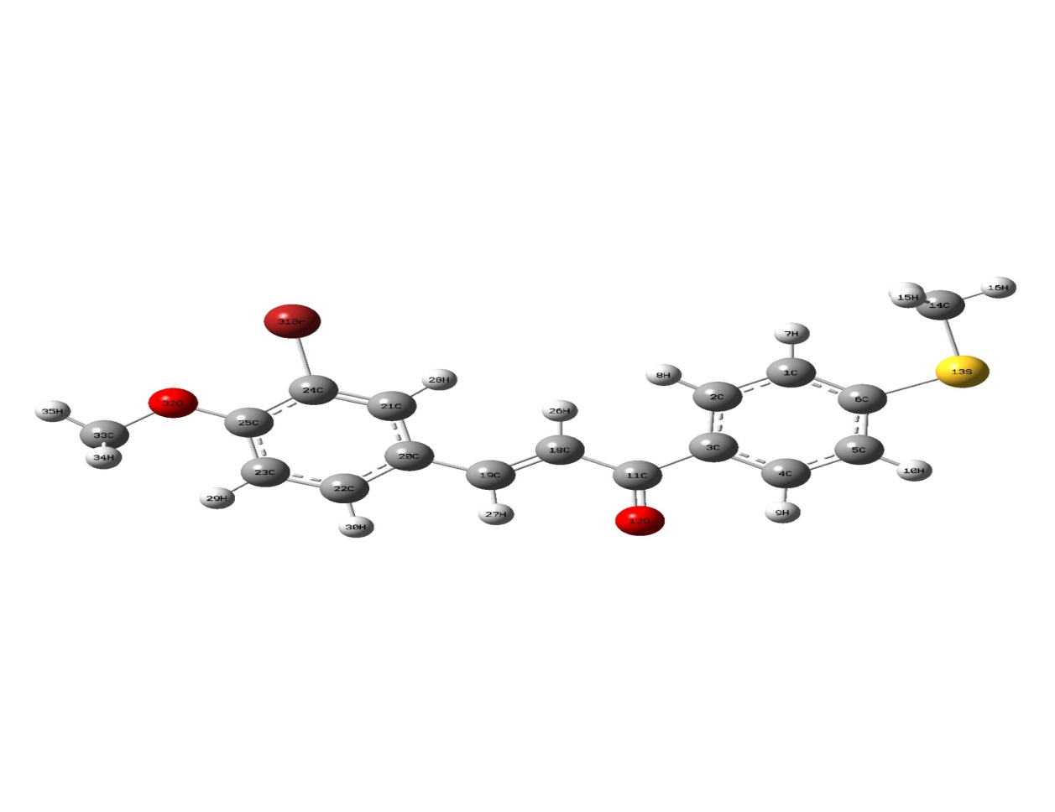

Fig. 1. Optimized Structure of (E)-3-(3-bromo-4-methoxyphenyl)-1-(4-(methylthio)phenyl)prop-2-en-1-one.

Table 1. Selected geometrical Parameters of the titled compound.

|  |  |  |  |  |  |
| --- | --- | --- | --- | --- | --- |
| Bond length | B3LYP/6-311 G (d, p) | Bond angle | B3LYP/6-311 G (d, p) | Dihedral angle | B3LYP/6-311 G (d, p) |
| C1-H7 | 1.08 | C6-S13-C14 | 102.97 | C5-C4-C3-C11 | -180 |
| C6-C5 | 1.4 | S13-C14-H16 | 105.09 | C2-C1-C6-S13 | -180 |
| C4-C5 | 1.4 | C3-C11-C18 | 120 | C4-C5-C6-S13 | -180 |
| C4-H9 | 1.08 | C3-C11-O12 | 120 | C6-S13-C14-H15 | 60 |
| C2-C3 | 1.4 | O12-C11-C18 | 120 | C1-C2-C3-C11 | 180 |
| C3-C11 | 1.49 | C11-C18-C19 | 120 | C2-C3-C11-O12 | -177 |
| C11-C18 | 1.48 | C18-C19-C20 | 129 | C4-C3-C11-O12 | 2.2 |
| C18-C19 | 1.35 | C11-C18-H26 | 119 | C4-C3-C11-C18 | -180 |
|  |  | C21-C24-Br31 | 120 | C2-C3-C11-C18 | 0 |
|  |  | Br31-C24-C25 | 119 | C3-C11-C18-C19 | -180 |
|  |  |  |  | C3-C11-C18-H26 | 0 |
|  |  |  |  | O12-C11-C18-H26 | -180 |
|  |  |  |  | O12-C11-C18-C19 | 1.0 |
|  |  |  |  | C11-C18-C19-H27 | 0.2 |
|  |  |  |  | C11-C18-C19-C20 | 180 |
|  |  |  |  | C20-C21-C24-Br31 | -180 |
|  |  |  |  | H28-C21-C24-Br31 | 0 |

**3.2. *Vibrational analysis***

FT-IR spectra were recorded in the range of 4000–400 cm-1 (solid phase) and are shown in Fig. 2a. The calculated vibrational spectrum in the gas phase is shown in Fig. 2b. This molecule has C1 symmetry. The title molecule has 36 atoms corresponding to 102 fundamental vibrational modes calculated at the B3LYP/6-311 G(d,p) level. There are 35 stretching modes, and 67 bending modes are pertained by the present compound. Some of the theoretical and experimental oscillations with intensities and assignments are shown in Table 2. Carbonyl stretching vibrations in the chalcone generally occur between 1750 and 1600 cm-1 [22]. We assign the carbonyl stretching vibration at 1648.8 cm-1 in the experimental spectrum and calculate theoretically at 1613 cm-1. These values are consistent with previously reported values for chalcone derivatives [23,24]. Aromatic C–H stretches are commonly found above 3000 cm-1 [25]. These vibrations are calculated in the 3097 to 3073 cm-1 range and are experimentally observed as a mixed vibrational band at 3065 cm-1. In-plane and out-of-plane C-H bending vibrations of aromatic rings and vinyl groups are observed at 1260, 881, and 802 cm-1 and calculated at 1267, 877, 814, and 790 cm-1. In previously published literature on chalcone derivatives, the C=C stretching frequency of the enone moiety was observed at 1592 cm-1 and calculated at 1588 cm-1 [23]. Here in the title molecule, this vibration is calculated at 1572 cm-1 and shown experimentally at 1583 cm-1.

The aromatic C═C stretching of the title compound was observed at 1545 cm-1 and was theoretically assigned to 1542 cm-1. The out-of-plane CH=CH bending mode at 959 cm-1 indicates the trans-geometry of alkenes. The current study observed the C-Br stretch at 666.3 cm-1 and calculated at 637 cm-1. The C-S stretching generally occurs in the range of 800–700 cm-1 [26]. The observed elongation with an experimental value of 732.82 cm-1 agreed with the theoretically observed value of 735 cm-1. According to Sharma et al. [27], the methoxy (O-CH3) stretching is observed at 1059 cm-1 by DFT/B3LYP/6-311G (d,p), and the experimental value is observed at 1041 cm-1. The oscillating system systematically described the FT-IR frequencies, and the TED analysis met the basic criteria shown in Table 2.

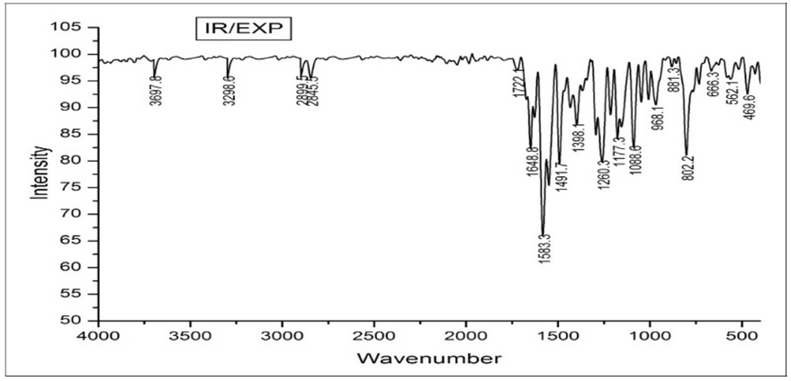

Fig. 2a. Experimental FT-IR spectrum of (*E*)-3-(3-bromo-4-methoxyphenyl)-1-(4-(methylthio) phenyl)prop-2-en-1-one.

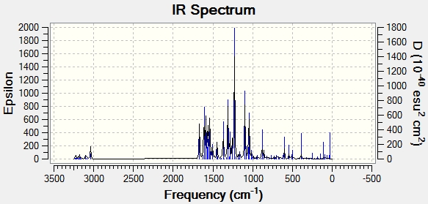

Fig. 2b. Theoretical FT-IR spectrum of (E)-3-(3-bromo-4-methoxyphenyl)-1-(4-(methylthio)phenyl)prop-2-en-1-one.

Table 2. FT-IR Vibrational and TED assignments of the (*E*)-3-(3-bromo-4-ethoxyphenyl)-1-(4-(methylthio)phenyl)prop-2-en-1-one.

|  |  |  |  |  |  |  |  |
| --- | --- | --- | --- | --- | --- | --- | --- |
| Modes | Calculated frequencies (cm-1) | | Observed frequencies (cm-1) | Reduced Mass | Force Constant | IR intensity | Assignments TED≥10% |
| Unscaled | aScaled | FT-IR |
| 6 | 3199 | 3073 | 3065 | 1.09 | 6.53 | 4.93 | γC2-H8 [93] |
| 9 | 3179 | 3054 | 3044 | 1.11 | 6.53 | 2.52 | γC14-H16 [75] |
| 13 | 3099 | 2977 | 2969 | 1.11 | 6.21 | 31.79 | γC33-H34 [100] |
| 15 | 3039 | 2920 | 2910 | 1.03 | 5.53 | 56.89 | γC33-H36 [92] |
| 16 | 1669 | 1604 | 1645 | 4.99 | 8.29 | 181.66 | γC11-O12 [58] |
| 17 | 1621 | 1557 | 1576 | 5.83 | 9.19 | 21.36 | γC21-C24 [10], γC22-C23 [41] |
| 19 | 1588 | 1526 | 1545 | 6.49 | 9.85 | 177.18 | γC2-C3 [55] |
| 29 | 1448 | 1391 | 1393 | 2.80 | 3.45 | 77.17 | γC23-H29 [22], βH30-C22-C23 [19] |
| 37 | 1296 | 1246 | 1254 | 1.44 | 1.48 | 8.49 | γC2-C3 [85] |
| 40 | 1252 | 1203 | 1184 | 2.53 | 2.29 | 7.25 | γC1-C2 [22], βH7-C1-C2 [16], βH8-C2-C1 [12], βH10-C5-C6 [18] |
| 41 | 1229 | 1181 | 1173 | 1.24 | 1.09 | 553.16 | γC20-C19 [12], γC11-C3 [12], βH8-C2-C1 [13], βH30-C22-C23 [10] |
| 45 | 1161 | 1115 | 1087 | 1.49 | 1.14 | 29.42 | γC3-C2 [29], βH10-C5-C6 [37] |
| 46 | 1099 | 1056 | 1041 | 3.06 | 2.19 | 256.51 | γS13-C6 [60] |
| 54 | 1011 | 972 | 959 | 1.36 | 0.80 | 30.38 | τH17-C14-S13-C6 [71] |
| 60 | 894 | 859 | 859 | 1.41 | 0.66 | 2.48 | τH29-C23-C25-C24 [60] |
| 63 | 858 | 824 | 797 | 4.99 | 2.13 | 21.58 | γO32-C25 [18], βBr31-C24-C21 [25] |
| 65 | 797 | 766 | 732 | 6.07 | 2.09 | 2.45 | δC11-C4-C2-C3 [27] |
| 70 | 677 | 651 | 634 | 7.12 | 1.84 | 4.89 | γS13-C14 [29], βC3-C2-C1 [44] |
| 74 | 542 | 521 | 551 | 5.51 | 0.92 | 25.23 | βC19-C18-C11 [45] |
| 77 | 494 | 475 | 464 | 6.56 | 0.91 | 2.64 | τH28-C21-C24-C25 [13], τC23-C22-C20-C19 [11], τC24-C25-C23-C22 [19], δBr31-C21-C25-C24 [25] |

**3.3. *NMR spectral analysis by GIAO method***

On comparing the calculated 1H and 13C NMR chemical shifts, the theoretical 1H chemical shift values are usually higher than the experimental values, and some proton values are significantly different from the experimental values. The spectrum clearly shows clusters of high-frequency absorption in the 7.0–8.5 ppm downfield region, presumably due to the presence of aromatic ring protons on both the phenyl rings. However, the alkylidene protons labeled as Hα and Hβ exhibit two distinct and characteristic absorptions centered at 7.320 and 7.711 ppm, respectively [28], indicating the coupling constant between the three σ bonds (JH-H) is about 16 Hz. We conclude that the two protons must have the E or trans-configuration from the obtained values of the coupling constants for these alkylidene protons (Hα and Hβ). Otherwise, the coupling constants should be much smaller or significantly lower than the J values observed for *cis* or *Z* configurations around the C=C bond. Generally, the chemical shift values for Hβ proton are slightly unshielded than Hα proton. This is probably due to forming of a formal positive charge at the allylic position (C-19) formed from resonance stabilization of the enone moiety. In this way, the Hβ protons at C-19 are more able to be unshielded than the Hα protons at C-18. Additionally, the simulated 1H-NMR spectral data and the experimental data are shown in Table 3, and the spectra are shown in Fig. 3.

From Fig. 4, the carbon signals from 111.87 to 157.59 ppm are due to the presence of aromatic ring carbons. The signal at 188.84 ppm indicates the C=O carbon present in the compound. A vinyl carbon Cα is identified at 120.57 ppm, and Cβ is observed at 142.70 ppm. The proton and carbon resonance values are in good agreement with experimental values, as shown in Table 3. The correlation between experimental and theoretical chemical shifts for 1H and 13C is shown in Fig. 5. Correlation analysis showed that the proton and carbon nucleus coefficients were found to be 0.9588 and 0.9305, respectively, and are correlated satisfactorily.

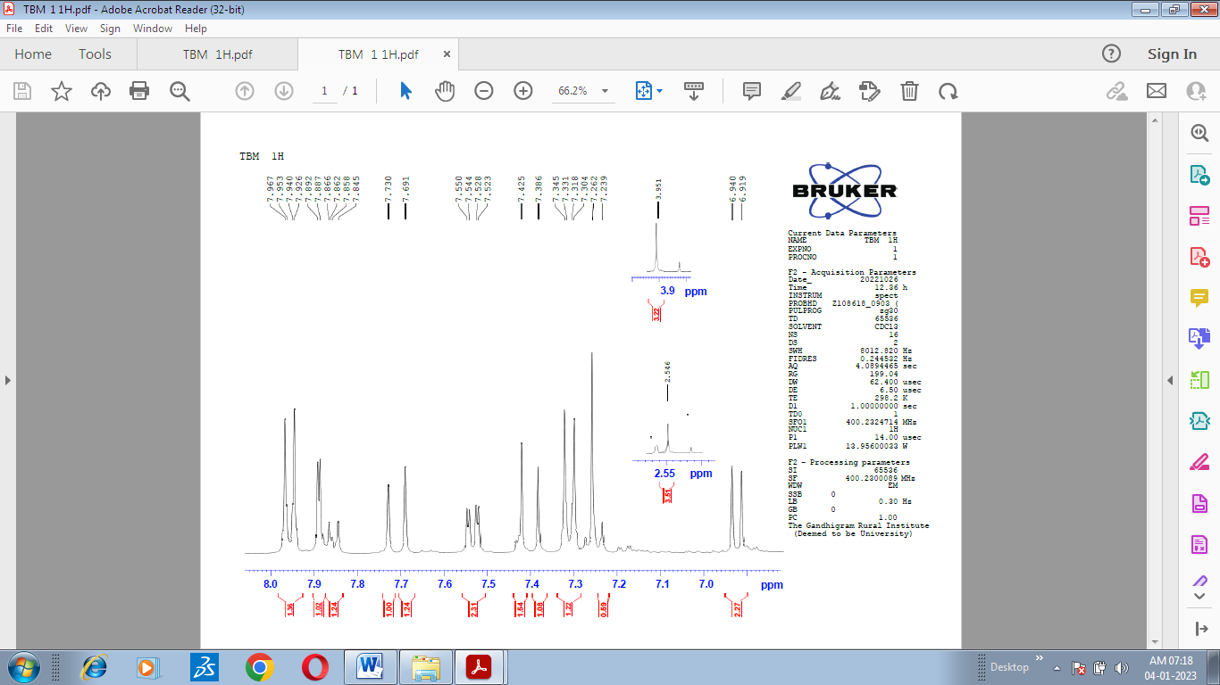

Fig. 3. 1H NMR Spectrum of (*E*)-3-(3-bromo-4-methoxyphenyl)-1-(4-(methylthio)phenyl)prop-2-en-1-one.

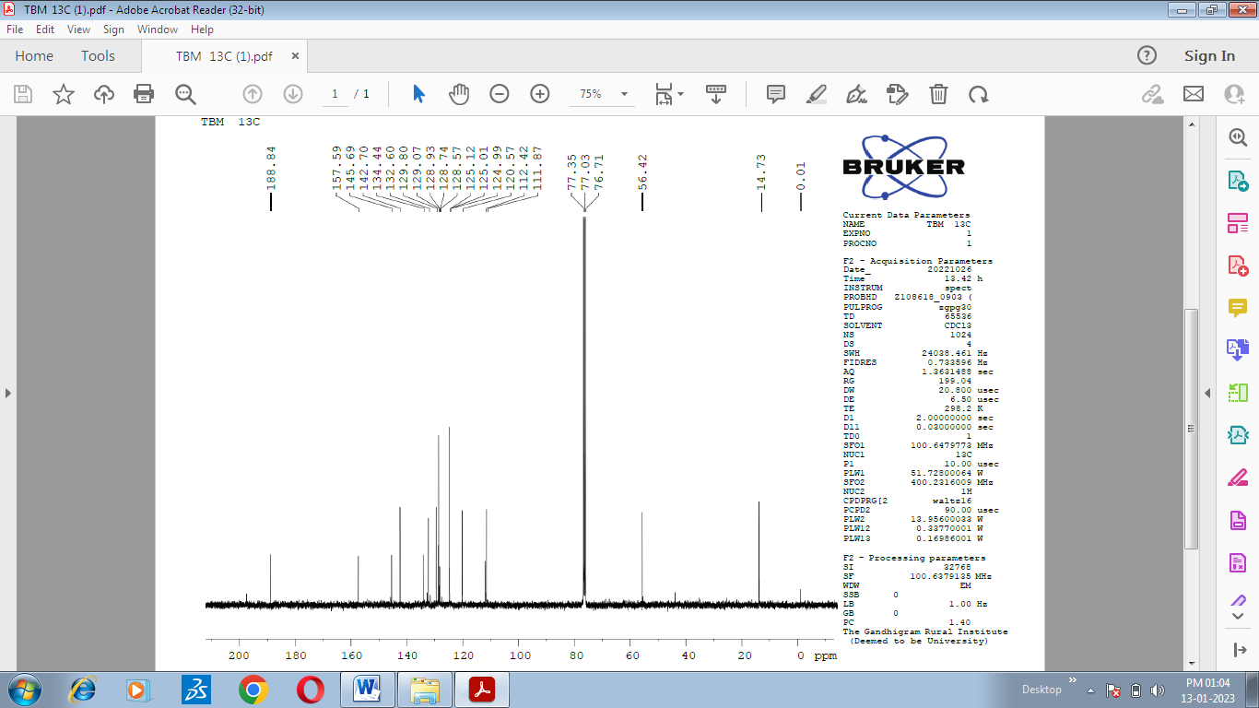

Fig. 4. 13C NMR Spectrum of (*E*)-3-(3-bromo-4-methoxyphenyl)-1-(4-(methylthio)phenyl)prop-2-en-1-one.

Table 3. The predicted and observed 1H and 13C NMR chemical shifts for the titled compound.

|  |  |  |
| --- | --- | --- |
| Atom | Chemical shift (ppm) | |
| B3LYP/6-311G(d.p.) | Experimental |
| 11C (carbonyl) | 191.818 | 188.84 |
| 25C | 159.414 | 157.59 |
| 19C (Cβ) | 144.927 | 142.70 |
| 6C | 157.137 | 145.69 |
| 24C | 134.75 | 111.87 |
| 18C (Cα) | 118.037 | 120.57 |
| 33C (methoxy) | 60.937 | 56.42 |
| 14C (methyl) | 27.484 | 14.84 |
| 26H | 7.29 | 7.40 |
| 27H | 7.769 | 7.71 |
| 28H (Hα) | 7.605 | 7.32 |
| 29H (Hβ) | 6.252 | 7.711 |
| 34H,36H (methoxy ) | 3.593 | 3.951 |
| 15H,17H (methyl) | 2.245 | 2.546 |

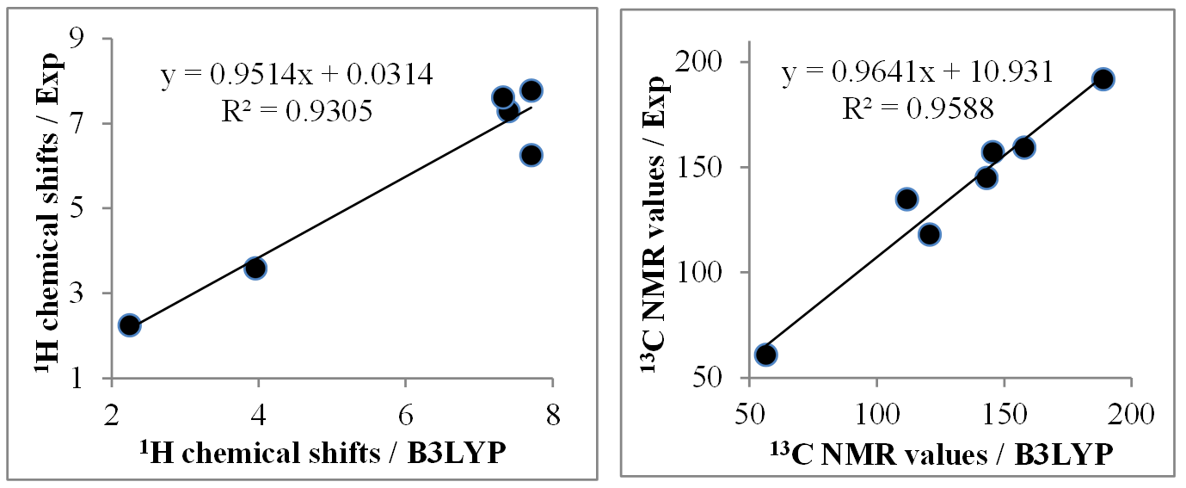

Fig. 5. Correlation diagram between theoretical and experimental NMR chemicals shifts.

**3.4. *UV-VIS spectral analysis***

The electronic transitions of the UV-Vis spectra of the title compounds were investigated using time-dependent density functional theory (TD-DFT) to calculate the transitions allowed in the gas phase. The electronic absorption spectrum of the title molecule was recorded experimentally with pure methanol as solvent. The experimental and simulated UV spectrum is shown in Fig. 6. The calculated UV-visible spectrum showed two strongly allowed transitions at λmax = 364 nm, f = 0.7392 and λmax = 329 nm, f = 0.2380. They corresponded to the experimental λmax value of 319 nm. The peaks observed in the theoretical spectrum can be attributed to the excitation of the C=O and –C=C– groups, so the assigned bands are due to the (n → π*) and (π → π*) transitions. In HOMO, the π-bonding electrons are distributed on the phenyl ring, the carbonyl oxygen atom, and the C=C moiety. LUMO, in electrons, is distributed throughout the molecule except for the methyl group.

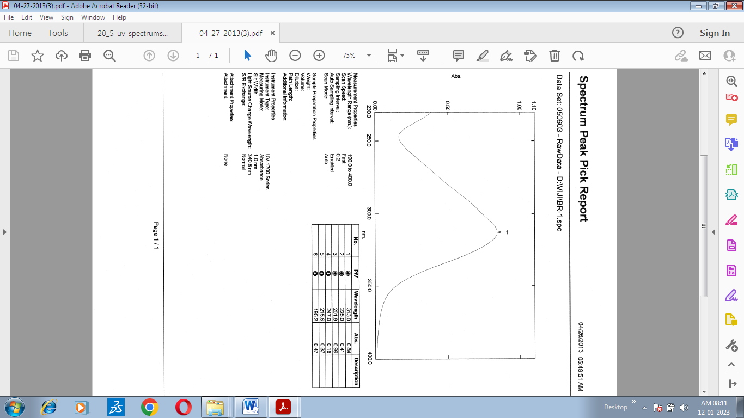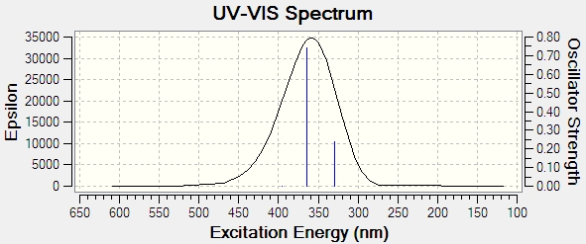

Fig. 6a. Experimental and simulated UV Spectrum of of (*E*)-3-(3-bromo-4-methoxyphenyl)-1-(4-(methylthio)phenyl)prop-2-en-1-one

**3.5. *HOMO and LUMO analysis***

The intermolecular charge transfer process from donor to acceptor units in molecular systems is characterized by the excitation of electron-shaped occupied orbitals (HOMO) to unoccupied orbitals (LUMO) and is described by quantum chemical approaches [29]. High HOMO energy levels represent compounds that are good nucleophiles, and low LUMO levels represent compounds that are good electrophiles [30]. The molecular frontier orbital energies are shown in Fig. 7. From Fig. 7, the values of EHOMO and E LUMO are found to be -5.96 eV and -2.17 eV, respectively. A HOMO-LUMO energy variation (ΔE) of 3.80 eV indicates a possible intramolecular charge-transfer interaction. A wide bandgap describes the hardness of the molecule, which is related to the non-reactivity of the molecule. Using the calculated HOMO and LUMO energies, we can obtain electrochemical parameters shown in Table 4, such as the global electrophilic index is ω = μ2/2η, the global hardness η = (I-A)/2, the chemical potential μ = -(I+A)/2 and the electronegativity (χ) is χ = (I+A )/2 and the global softness ν = 1/ η was called the global reactivity parameter [31-35].

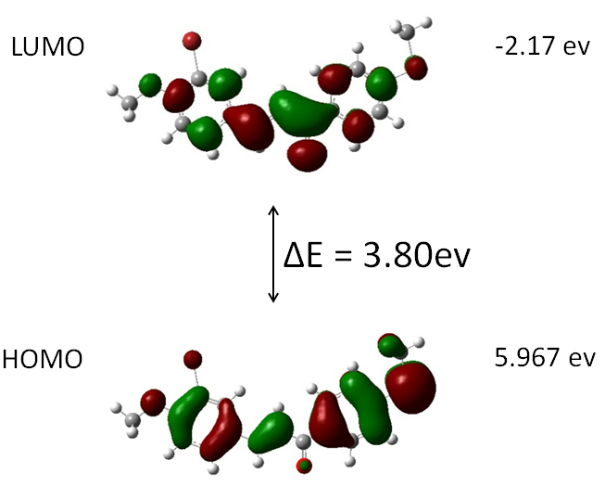

Fig. 7. HOMO-LUMO of (E)-3-(3-bromo-4-methoxyphenyl)-1-(4-(methylthio)phenyl)prop-2-en-1-one.

Table 4. HOMO and LUMO calculated values of (E)-3-(3-bromo-4-methoxyphenyl)-1-(4-(methylthio)phenyl)prop-2-en-1-one by B3LYP/6-311G (d,p) method.

|  |  |
| --- | --- |
| Parameters | Calculated values |
| EHomo(a u) | -5.96 |
| ELumo(a.u) | -2.17 |
| Energy gap(a.u) | 3.80 |
| Ionization energy(I) | 5.96 |
| Electron affinity(A) | 2.17 |
| Global hardness(η) | 1.8977 |
| Chemical potential(µ) | -4.0665 |
| Electrophilicity index(𝜔) | 4.356 |
| Chemical softness(s) | 0.5269 |

**3.6. *Molecular electrostatic potential (MEP) analysis***

A molecular electrostatic potential (MEP) map is a very useful three-dimensional diagram used to visualize molecules' charge distribution and physicochemical properties. MEP images are also used to predict electrophilic, nucleophilic, and neutral electrostatic potential ranges in terms of color gradations, providing a suite of relationships between molecular structure and physicochemical properties and biological Useful for studying recognition and hydrogen bonding interactions. [36,37]. The MEPs of the title compounds were theoretically calculated based on the basic set B3LYP/6-311G (d,p). In the title compound, the red region of negative potential exerts over the oxygen atoms, indicating electrophilicity character, thus presenting a reactive site near the C=O group. The most positive regions are on the hydrogen atoms, exhibiting the molecular system's strongest attraction (nucleophilic reaction sites). Negative sites were on the oxygen atoms of carbonyl and methoxy groups. Positive sites are indicated on the phenyl ring (Fig. 8).

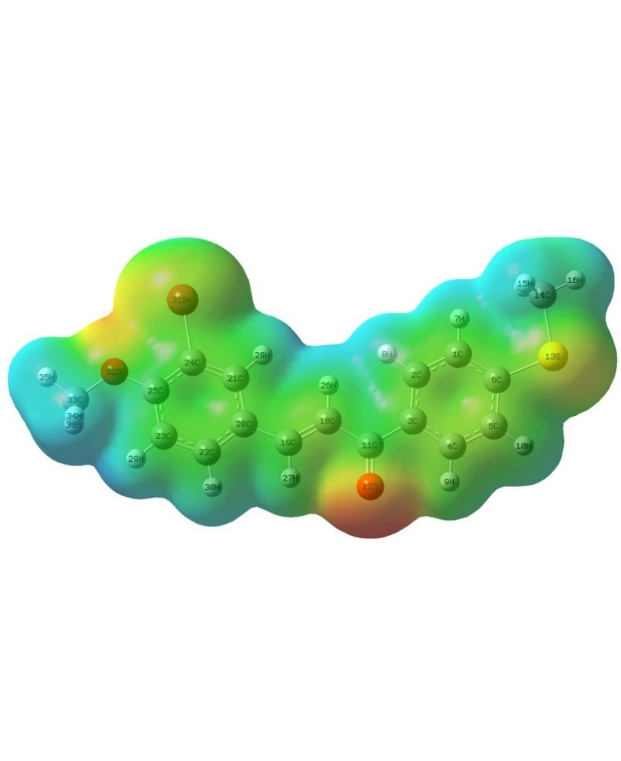

Fig. 8. Molecular Electrostatic Potential (MEP) of (E)-3-(3-bromo-4-methoxyphenyl)-1-(4-(methylthio)phenyl)prop-2-en-1-one

**3.7. *Mulliken atomic charge analysis***

Mulliken atomic charge analysis is useful for understanding chemical potentials and ionization potentials. Atomic charge affects the dipole moment, polarizability, electronic structure, and various molecular properties of the system [38]. The Mulliken atomic charge, which is hydrogen added to the heavy atom, was calculated using the B3LYP/6-311G(d,p) basis set method and is shown in Fig. 9. Atomic charge calculations, shown in Table 5, showed that the carbonyl group connecting the two phenyl rings affects the charge. As expected, the presence of the ketone moiety increased the electronegativity of the C11 atom.



Fig. 9. Milliken Charge Distribution of (*E*)-3-(3-bromo-4-methoxyphenyl)-1-(4-(methylthio) phenyl)prop-2-en-1-one.

The C25 (0.3449), C33 (0.2618), and C11 (0.1984) are due to highly electronegative oxygens bonded to carbon atoms. The atomic charges of C3, C6, O12, C14, C24 and O32 have negative charges. Atom O32 (-0.4912) has a larger negative atomic charge. Finally, the larger the positive charge C25 and the negative charge O32, the larger the active site of the compound.

Table 5. Mulliken Charges of (*E*)-3-(3-bromo-4-methoxyphenyl)-1-(4-(methylthio)phenyl)prop-2-en-1-one.

|  |  |  |  |
| --- | --- | --- | --- |
| Atoms | Mulliken Charges | Atoms | Mulliken Charges |
| 1C | 0.034387 | 19C | 0.065661 |
| 2C | 0.020712 | 20C | 0.078362 |
| 3C | 0.02705 | 21C | 0.04601 |
| 4C | 0.04966 | 22C | -0.02263 |
| 5C | 0.039285 | 23C | 0.013122 |
| 6C | -0.27872 | 24C | -0.35741 |
| 11C | 0.262347 | 25C | 0.320066 |
| 12O | -0.44645 | 31Br | 0.196038 |
| 13S | 0.271959 | 32O | -0.52487 |
| 14C | -0.08717 | 33C | 0.294834 |
| 18C | -0.00223 |

**3.8. *NLO properties***

Higher values of dipole moment (μ) and hyperpolarizability (β) indicate more active NLO properties. This molecule's dipole moment and first hyperpolarizability are 2.546 Debye and 3.223 × 10-30 esu), as shown in Table 6. This hyperpolarizability value is eight times higher than that of urea (μ and β of urea are 1.3732 Debye and 0.3728 × 10-30 esu) [39], and the resulting values indicate that this compound is an excellent NLO material. Suppose we know the dipole moment of a molecule. In that case, we can investigate the interaction between dipoles occurring within the atoms of that molecule, and the higher the dipole moment, the stronger the interaction between molecules.

Table 6. Dipole Moment Components of (E)-3-(3-bromo-4-methoxyphenyl)-1-(4-(methylthio)phenyl)prop-2-en-1-one.

|  |  |
| --- | --- |
| Dipole vector components | Dipole moment, µ (Debye) |
| µx | 2.313 |
| µy | 0.2553 |
| µz | 1.033 |
| µtotal | 2.546 |
| Parameters | Hyperpolarizability |
| βxxx | 249.09 |
| βxxy | 65.27 |
| βxyy | 66.04 |
| βyyy | -106.82 |
| βxxz | 67.91 |
| βxyz | 28.04 |
| βyyz | 7.35 |
| βxzz | 43.69 |
| βyzz | -26.66 |
| βzzz | 0.91 |
| β0 | 3.223x10-30esu |

**3.9. *Molecular docking analysis***

Docking studies were performed with Autodock 4.2 tool. The titled compound was docked with the active site of the enzyme COX-2 (PDB ID: 3LN1) and showed better docking values. Before docking, the gastiger charges and polar hydrogens were added, and it contains five rotatable bonds. From the results, it can be concluded that the synthesized compound showed a good binding affinity with the proteases used in this study. The observed binding energy is -8.3 Kcal/mol. Four hydrogen bonding interactions between the target molecule and protein are observed. The interaction between donor SER132 and the target compound's acceptor methoxy oxygen is observed at a distance of 3.058 Å. A hydrogen-bonding interaction between ARG202 and the phenyl group is observed at a distance of 3.136 Å. This result also implies that two electrostatic and three hydrophobic interactions occurred between the protease and the titled molecule. The compound, therefore, exhibits good anti-inflammatory properties with the 3LN1 receptor.

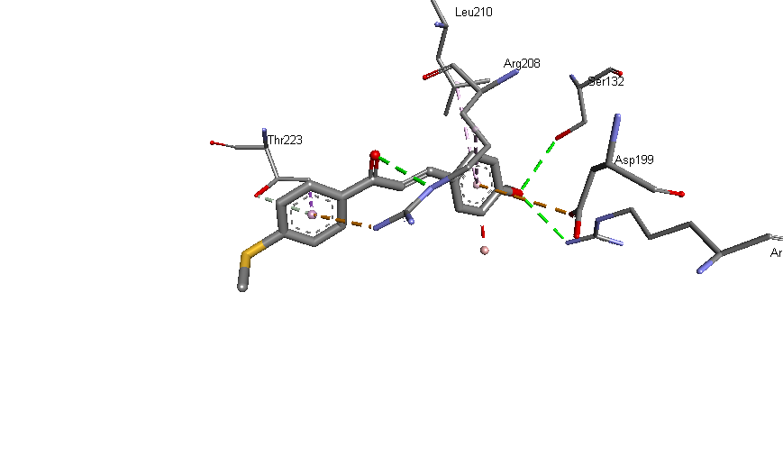 

Fig. 10a. 2D visualization of docking interactions between molecule and protein.

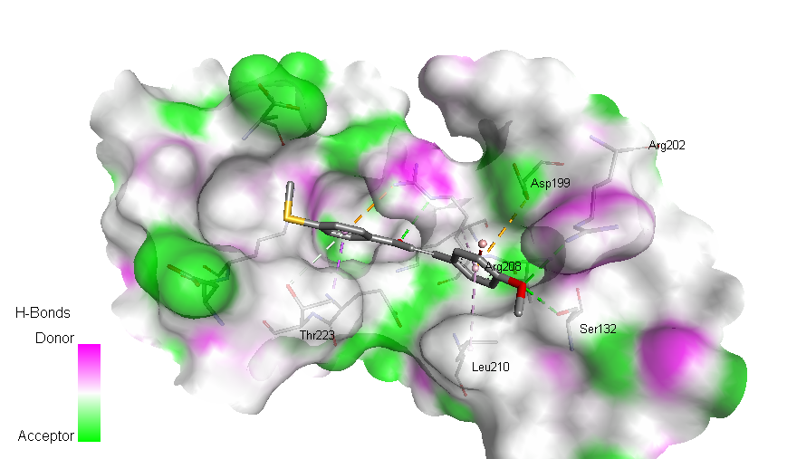

Fig. 10b. 3D visualization of docking interactions between molecule and protein.

The results are displayed in Table 7, and the interactions are given in Figs. 10a and 10b for 2D and 3D visualization respectively.

Table 10. Results of molecular docking interactions.

|  |  |  |
| --- | --- | --- |
| Interactions | Receptor residue | Distance (A°) |
| Hydrogen Bond (4) | SER 132; ARG 202; ARG 208 and THR 223 | 3.05; 3.14; 3.16 and 4.18 |
| Pi-Alkyl Interactions (2) | ARG 208; LEU 210 | 5.17; 4.97 |
| Van der waals interactions | ARG 208; ASP 199 | 4.07; 4.79 |
| Other interactions | THR 223 | 3.86 |

**4. Conclusion**

A synthetic molecule of (*E*)-3-(3-bromo-4-methoxyphenyl)-1-(4-(methylthio)phenyl)prop-2-en-1-one was synthesized and analyzed by IR, 1H and 13C NMR characterization method. Theoretical studies have confirmed that the molecule has the *E*-configuration. The theoretically calculated bond lengths, bond angles, and λmax (UV spectra) are in good agreement with experimental results. The HOMO-LUMO energy gap agrees well with experimental results. The FT-IR spectrum of the title molecule shows a good correlation with the theoretically assigned vibrational modes. The electronic spectral properties of the compounds under study were calculated by the TD-DFT method using FT analysis on the B3LYP/6-311G basis set. The chemical reactivity parameters indicated that the title compound has excellent chemical strength and stability. The compounds' electrophilic and nucleophilic reaction sites were obtained by MEP surface analysis. Dipole moment and hyperpolarizability values were calculated to determine the NLO activity of the title chalcone. Furthermore, molecular docking studies with selected proteins imply good anti-inflammatory properties.

**Acknowledgment**

The authors wished to thank the Centre for Instrumentation, Gandhigram Rural Institute (Deemed to be University) Dindigul, for recording the NMR spectra of all compounds.

**References**

1. A. M. R. Teixeira, H. S. Santos, P. N. Bandeira, M. S. S. Julião et al., J. Mol. Strct. **1179**, 739 (2019). <https://doi.org/10.1016/j.molstruc.2018.11.075>
2. T. S. D. Freitas, J. D. C. Xavier, R. L. S. Pereira, J. E. Rocha et al., FEMS Microbio Lett. **367**, 1 (2020). <http://dx.doi.org/10.1093/femsle/fnaa124>
3. P. T. Silva, T. S Freitas, D. M. Sena Jr, P.N. Bandeira et al., Appl. Sci. **10**, 4713 (2020). <http://dx.doi.org/10.3390/app10144713>
4. H. M. Vagdevi, K. P. Latha, V. P. Vaidya, M. L. V. Kumar, and K. S. R. Pai, Ind. J. Pharm. Sci., **63**, 286 (2001).
5. S. Ashraf, S. Hameed, M. N. Tahir, and M. M. Naseer, Monatsh. Chem. **148,** 1871 (2017). <https://doi.org/10.1007/s00706-017-1995-8>
6. S. Samshuddin, B. Narayana, B. K. Sarojini, D. N. Shetty, and N. S. Kumari, Int. J. Med. Chem. **2012,** 1 (2012). <https://doi.org/10.1155/2012/530392>
7. B. A. Bhat, K. L. Dhar, S. C. Puri, A. K. Saxena, M. Shanmugavel, and G. N. Qazi, Bioorg. & Med. Chem. Lett. **15**, 3177 (2005). <https://doi.org/10.1016/j.bmcl.2005.03.121>
8. V. Monga, K. Goyal, M. Steindel, M. Malhotra, D. P. Rajani, and S. D. Rajani, Med. Chem. Res. **23**, 2019 (2014). <https://doi.org/10.1007/s00044-013-0803-1>
9. P. K. Arora, A. Mittal, G. Kaur, and A. Chauhan, Int. J. Pharm. Sci. Res. **4**, 419 (2013). <http://dx.doi.org/10.13040/IJPSR.0975-8232>
10. D. Coskun, B. Gunduz, and M. F. Coskun, J. Mol. Str. **1178**, 261 (2019). <https://doi.org/10.1016/j.molstruc.2018.10.043>
11. A. Aboelnaga, A. E. E. Mansour, A. Hoda, and H. M. Ahmed, J. Kor. Chem. Soc. **65** (2021). <https://doi.org/10.5012/jkcs.2021.65.2.113>
12. M. Najafian, A. Ebrahim-Habibi, P. Yaghmaei, K. Parivar, and B. Larijani, Acta. Biochim. Polo. **57**, 553 (2010). <https://doi.org/10.18388/abp.2010-2443>
13. G. Wang, W. Liu, Z. Gong, Y. Huang, Y. Li, and Z. Peng, Bioorg. Chem. **95**, ID 103565 (2020). <https://doi.org/10.1016/j.bioorg.2019.103565>
14. H. L. Qin, Z. W. Zhang, R. Lekkala, H. Alsulami, and K. P. Rakesh, Eur. J. Med. Chem. **193**, 112215 (2020). <https://doi.org/10.1016/j.ejmech.2020.112215>
15. T. Janković, N. Turković, J. K. Stevuljević, Z. Vujić, and B. Ivković, Chemico-bio. Interact. **324**, ID 109084 (2020). <https://doi.org/10.1016/j.cbi.2020.109084>
16. A. A. Ahamed and M. M. Sihabudeen, Asian J. Pharm. Pharmaco. **3**, 247 (2017).
17. D. Kamalakkannan, R. Senbagam, G. Vanangamudi, and G. Thirunarayanan, J. Mol. Struct. **1264**, ID 133218 (2022). <https://doi.org/10.1016/j.molstruc.2022.133218>
18. M. J. Frisch et. al, Gaussian-09, Revision A.01, Gaussian, Inc., (Wallingford, CT, 2009).
19. R. Dennington, T. Keith, and J. Millam, GaussView, Version 5, Semichem Inc (Shawnee Mission KS, 2009).
20. M. H. Jamroz, Spectrochim. Acta Part A, **114**, 220 (2013). <https://doi.org/10.1016/j.saa.2013.05.096>
21. S. Bharanidharan, H. Saleem, S. Subaschchandrabose, M. Suresh, and N. Ramesh Babu, Arch. Chem. Res. **1**(2:7), 1 (2017). <https://doi.org/10.21767/2572-4657.100007>
22. J. Dhevaraj, S. Vembu, S. Pazhamalai, and M. Gopalakrishnan, Ori. J. Chem. **35**, 577 (2019). <https://doi.org/10.13005/ojc/350211>
23. D. A. Zainuri, S. Arshad, C. N. Khalib, I. A. Razak et al., J. Mol. Struct. **1128**, 520 (2013). <https://doi.org/10.1016/j.molstruc.2016.09.022>
24. S. R. Maidur, P. S. Patil, A. Ekbote, T. S. Chia, and C. K. Quah, Spectrochim Acta Part A Mol. Biomol. Spectrosc. **184**, 342 (2017). <https://doi.org/10.1016/j.saa.2017.05.015>
25. S. Yadav, A. Khare, K. K. Yadav, P. C. Maurya1, A. K. Singh, and A. Kumar, J. Sci. Res. **14**, 79 (2022). <https://doi.org/10.3329/jsr.v14i1.53339>
26. S. Zainuri, N. C. Arshad, M. F. Khalib, Zaini, and I. B. Razak, IOP Conf. series: J. Phys.: Conf. series **1083**, ID 012046 (2018). <https://doi.org/10.1088/1742-6596/1083/1/012046>
27. B. Sharma, M. K. Yadav, and M. K. Singh, Arch. Appl. Sci. Res. **3**(2), 334 (2011).
28. A. N. Prabhu, A. Jayarama, K. S. Bhat, and V. Upadhyaya, J. Mol. Struct. **1031**, 79 (2013). <https://doi.org/10.1016/j.molstruc.2012.06.057>
29. S. Sherzaman, M. N. Ahmed, B. A. Khan, T. Mahmood, K. Ayub, and M. N. Tahir, J. Mol. Struct. **1148**, 388 (2017). <https://doi.org/10.1016/j.molstruc.2017.07.054>
30. R. Mishra, A. Srivastava, A. Sharma, P. Tondon, C. Baraldi, and M. C. Gameroni, Spectrochem. Acta. Mol. Biomol. Spectro. **101A**, 335 (2013). <https://doi.org/10.1016/j.saa.2012.09.092>
31. R. G. Parr, L. V. Szentpaly, and S. Liu, J. Am. Chem. Soc. **121**, 1922 (1999). <https://doi.org/10.1021/ja983494x>
32. R. G. Parr, R. A. Donnelly, M. Levy, and W. E. Palke, J. Chem. Phys. **68**, 3801 (1978). <https://doi.org/10.1021/ja004105d>
33. P. K. Chattaraj and D. R. Roy, Chem. Rev. **107**, 64 (2007). <https://doi.org/10.1021/cr078014b>
34. A. Lesar and I. Milosev, Chem. Phys. Lett. **483**, 198 (2009). <https://doi.org/10.1016/j.cplett.2009.10.082>
35. N. R. Sheela, S. Muthu, and S. Sampathkrishnan, Spectrochim. Acta Part A: Mol. Biomol. Spectro. **120**, 237 (2014). <https://doi.org/10.1016/j.saa.2013.10.007>
36. R. Parthasarathi, V. Subramanian, D. R. Roy, and P. K. Chattaraj, Bioorg. Med. Chem. **12**, 5533 (2004). <https://doi.org/10.1016/j.bmc.2004.08.013>
37. D. A. Zainuri, I. A. Razak, and S. Arshad, Acta Cryst. E: **74**, 780 (2008). <https://doi.org/10.1107/S2056989018006527>
38. K. Arulaabaranam, S. Muthu, G. Mani, and S. Sevvanthi, J. Mol. Struct. **1220**, ID 128639 (2020). <https://doi.org/10.1016/j.molstruc.2020.128639>
39. Z. Zhou and H.V. Navangul, J. Phys. Org. Chem. **3**, 784 (1990). <https://doi.org/10.1002/poc.610031203>

1. * *Corresponding author*: [[[drningarsal@gmail.com](mailto:mahbubchem@cu.ac.bd)](mailto:samirkvaidya@yahoo.co.in)](mailto:deb_anindita@yahoo.com)