Available Online

J. Sci. Res. **16** (2), 471-477 (2024)

**JOURNAL OF**

**SCIENTIFIC RESEARCH**

www.banglajol.info/index.php/JSR



**Publications**

Effects on Structural and Optical Properties of PMMA by Integration with Cu Nanoparticles

Alisha1[1]*, D. Garg2

1Department of Physics, RKSD College, Kaithal, India

2Department of Computer Science and Engineering, NIT Kurukshetra, India

Received 12 August 2023, accepted in final revised form 9 March 2024

Abstract

Cu-PMMA nanocomposite films have been prepared via ex-situ chemical route by reduction of cupric chloride dissolved in aqueous CTAB solution with hydrazine and then incorporated the prepared Cu nanoparticles in a solution of Polymethylmethacrylate (PMMA) in chloroform and cast into thin films. Optical and structural characterizations of resulting nanocomposite films were performed using UV-visible spectroscopy and Transmission Electron Microscopy (TEM). Characteristic Surface Plasmon Resonance (SPR) peak of Cu nanoparticles was observed at about 2.14 eV (577 nm) in absorption spectra of Cu-PMMA nanocomposite films. From the observation of absorption spectra, the optical band gap and Urbach’s energy values have been calculated. Band gap values of Cu-PMMA nanocomposite films were found to decrease from 3 eV to 2.4 eV, while Urbach’s energy values increased with the increase in the concentration of Cu nanoparticles in PMMA. The decrease in the optical band gap and increase in Urbach’s energy values indicated the modifications in the optical band structure of the PMMA matrix on the incorporation of Cu nanoparticles. TEM micrograph revealed spherical Cu nanoparticles embedded in PMMA with an average diameter of 6.5+ 2.5 nm.

*Keywords* Nanocomposites; Cu nanoparticles; Surface plasmon resonance (SPR); Mie theory.

© 2024 JSR Publications. ISSN: 2070-0237 (Print); 2070-0245 (Online). All rights reserved.

doi: [https://dx.doi.org/10.3329/jsr.v16i2.68155](http://dx.doi.org/10.3329/jsr.v16i2.68155) J. Sci. Res. **16** (2), 471-477 (2024)

1. Introduction

Nanocomposites consisting of metal-nanoparticles have been broadly used in optical devices [1], sensors [2], light emitting diodes [3] and organic solar cells [4] etc. Nowadays, much interest has arisen in acrylic polymers, especially poly(methylmethacrylate) (PMMA). PMMA has been used widely because of its well-known optical properties, easy processability, high flexibility, and the ability to integrate optical functions [5]. It also has a high transmittance (92 %), high mechanical strength, is lightweight, has good resistance to ultraviolet light, and has outdoor aging characteristics of electrical properties. The structural and optical properties of PMMA can be modified through the combination of inorganic particles such as metal nanoparticles Ag, Au, and Cu, etc. A specific feature of metal nanoparticles is their interaction with light. The specific intrinsic energy states of the nanoparticles result in a characteristic light absorption connected with the plasmonic states of the particles [6]. Cu metal nanoparticles have great significance in all industries, particularly in the electrical sector, due to their low cost. Cu nanoparticles also have potential applications as fillers in polymers as lubricants, and they are used in ink and metallic coating [7].

Metal-polymer nanocomposites have been prepared using different methods by several researchers, such as gamma and ultraviolet irradiation [8], ultrasound radiation [9], and chemical reduction in-situ methods [10]. However, only a few reports of hydrophobic polymer/Cu nanocomposite by blending technique have appeared due to the incompatible nature of nanoparticles with a polymer matrix.

In the present work, we synthesized Cu nanoparticles of size 6-7 nm and dispersed them into the solution of PMMA in chloroform. The resulting solution was cast into thin films. Structural and optical characterization of Cu-PMMA nanocomposite films was performed using UV-VIS absorption spectroscopy and Transmission Electron Microscopy (TEM).

**2. Experimental**

**2.1. *Materials***

In two separate beakers, 5 mM hydrazine and 1 mM cupric chloride aqueous solution were dissolved in 0.3 mM aqueous CTAB solution. The pH of the cupric chloride solution was adjusted to 10 by adding ammonia solutions. Both the solutions were mixed under constant stirring. The solution of cupric chloride became colorless initially with the addition of hydrazine and then gradually turned the wine reddish. This wine-reddish coloration revealed the formation of Cu nanoparticles. The resulting solution was centrifugated to separate the Cu nanoparticles [11]. Cu nanoparticles thus obtained get dispersed in chloroform and then mixed with the solution of chloroform ultrasonically. The resulting solution was cast onto a petri dish to grow nanocomposite films. The thickness of Cu-PMMA nanocomposite films was found to be about 25 µm.

**2.2. *Instruments***

The optical properties of PMMA and Cu-PMMA nanocomposite films were analyzed using a Shimadzu Double Beam Double Monochromator Spectrophotometer (UV-2550), equipped with an integrating sphere assembly ISR-240A in the wavelength range 190-900 nm with a resolution of 0.5 nm. The absorption and transmission spectra were recorded by taking air as a reference, whereas for recording reflection spectra, BaSO4 was taken as a reference. The morphology of Ag nanoparticles embedded in PMMA has been studied using a TEM (Hitachi H-7500). For TEM images, a small quantity of nanocomposite film was added to methanol and sonicated for 20 minutes via a sonication bath, and then a few drops of the nanocomposite film solution were deposited on a carbon-coated copper grid. The grid was dried for 5-10 min so that the excess solvent gets evaporate.

**3. Results and Discussion**

Fig. 1 reveals the UV-visible absorption spectra of PMMA and Cu-PMMA nanocomposite films in the energy range of 1.5 eV to 5 eV. In the absorption spectra of the PMMA matrix, two peaks were observed at 4.23 eV and 3.56 eV. The presence of these peaks can be recognized in the n→π*transition of C=O and C–O bonds present in the PMMA matrix [12]. Broad absorption band, also known as surface plasmon resonance (SPR) absorption, was observed at about 2.14 eV (577 nm) in Cu-PMMA nanocomposite films [13] shown in Fig. 1 (curves b-d). This SPR band is attributed to the collective oscillations of the free electrons of Cu nanoparticles stimulated by incident light. The position of the SPR band depends on the size, shape, and concentration of the incorporated metal nanoparticles and the dielectric constant of the host matrix [8,14]. The intensity of the SPR band increases with increasing concentration of Cu nanoparticles in the PMMA matrix, and it also shifts towards higher energy. This blue shift may be due to the interaction of Cu nanoparticles with PMMA at high concentrations [6]. The absorption spectra of Cu-PMMA nanocomposite films were further analyzed to determine the size of Cu nanoparticles, assuming the free particle behavior of the conduction electrons, using Eq. (1) [12].

$d = \frac{hv_{f}}{{π ΔE}_{\frac{1}{2}}}$ (1

where d is the diameter of the Cu nanoparticle, vf (1⋅5 × 106 m/s) is the Fermi velocity of electrons in bulk silver, h is Planck’s constant, and ΔE1/2 is the FWHM of the SPR band. The Eq. (1) can be applied for the Cu nanoparticles having a size not greater than the mean free path of the electrons in bulk Cu metal. The diameter of Cu nanoparticles from absorption spectra comes out to be about 6-7 nm.



Fig. 1. Absorption Spectra of (a) PMMA and Cu-PMMA nanocomposite films having (b) 0.12 wt% (c) 0.15 wt% (d) 0.20 wt% Cu nanoparticles.



Fig. 2. UV-Visible absorption spectra of Cu-PMMA nanocomposite a) theoretically measured using the Mie theory model b) experimentally.

Classical Mie scattering theory was used for theoretical estimation of the SPR peak position of isolated Cu nanoparticles of diameter 6 nm embedded in PMMA matrix [12] using “Mieplot 4614” software. Mie theory describes the scattering or absorption of electromagnetic radiation from spherical particles based on their size. Fig. 2 reveals simulated absorption spectra of the isolated Cu nanoparticle (when the diameter is 6 nm) based on the Mie theory model as a function of wavelength and the SPR absorption spectra recorded experimentally. From this Fig., the SPR peak is observed at 577 nm for the spherical Cu nanoparticles of size 6 nm incorporated in the PMMA matrix. The broadening of the SPR peak may be due to the wider size distribution of prepared Cu nanoparticles. Fig. 2 shows a good agreement between the theoretically estimated and experimentally measured value of the SPR peak position of Cu nanoparticles incorporated in the PMMA matrix.The optical band gaps of the virgin PMMA and Cu/PMMA nanocomposite films were determined from the first absorption edge of absorption spectra. The absorption coefficient α, as a function of photon of energy, E (E > Eg) can be expressed by the Davis and Mott formula [5] using Eq. (2):

$α\left(ν\right)=B{\left(E-Eg\right)}^{r }$ (2)

Where B is a constant, also known as Tauc’s constant, Eg is the optical band gap of the specimen, E is the energy of the incident photon, and r is an index having the values of 2, 3, 1/2, and 3/2, depending on the nature of the electronic transition. Fig. 3 illustrates the dependence (αhν)1/2 on the photon energy hν (eV) for the Cu/PMMA nanocomposite films, showing a linear behavior that can be considered as evidence of an indirect transition (i.e., for r =2). The optical gap was estimated from the intercept on the energy axis of the linear fit of the large energy data of the plot. The indirect band gap for virgin PMMA films lies at 3eV, while for Cu/PMMA nanocomposite films, the value is found to decrease to 2.4 eV. The decrease of the optical energy gap with an increase in dopant concentration may be due to modifying the electronic structure of the PMMA matrix due to the appearance of various localized states within the band gap [5].

In the energy range E < Eg, the optical absorption coefficient normally shows a tail (Urbach’s tail) which can be expressed using Eq. (3):

$α\left(hν\right)=α_{0}\exp\left(\frac{hν}{E_{u}}\right)$ (3)

where αo is a constant, hν is the incident energy, and Eu is the Urbach’s energy. The curves of Ln α vs. hν were plotted, as shown in Fig. 4. The values of Eu were calculated as the reciprocal of the slope of the linear portion of the plots. The values of Eu werefound to be increased from 0.16 eV in virgin PMMA to 0.43 eV in Cu/PMMA nanocomposite films. The increase in values of Eu indicated an increase in various defect levels in the optical band gap of Cu/PMMA nanocomposite films. Eu is a function of the structural disorder of the material [7].

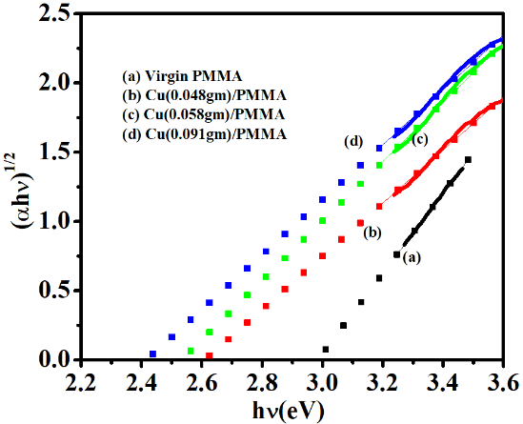

Fig. 3. (αh𝛎)1/2 versus hν plots for the Virgin PMMA and Cu/PMMA nanocomposite films.

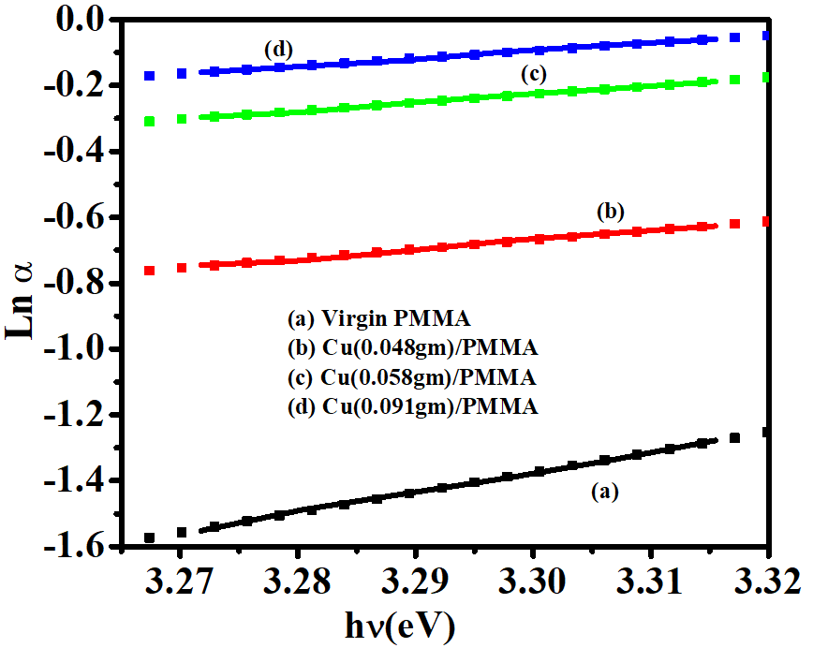

Fig. 4. Ln α vs hν plots for the virgin PMMA and Cu/PMMA nanocomposite films.

The shape, size, and distribution of Cu nanoparticles in PMMA were investigated at room temperature using TEM. The average diameter for spherical Cu nanoparticles in Cu-PMMA containing 0.2 wt% Cu nanoparticles was found to be 6.5 + 2.4 nm, which is consistent with the result obtained from the UV-visible spectrum. Fig. 5 shows the TEM image of the Cu(0.2 wt%)-PMMA nanocomposite film. It is clearly noticeable from this figure that Cu nanoparticles embedded in the PMMA matrix are uniformly dispersed within the polymer matrix. TEM image shows the spherical shape of Cu nanoparticles.

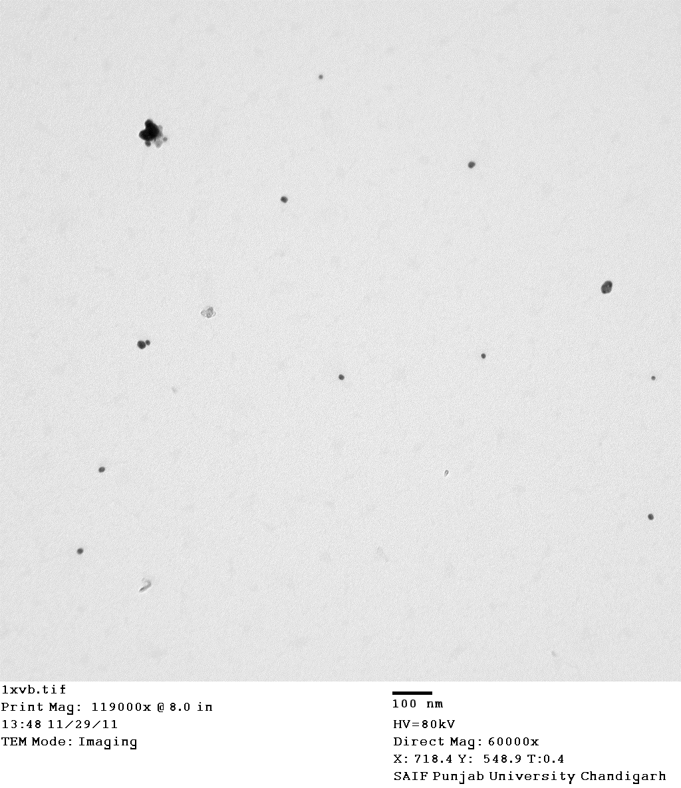

Fig. 5. TEM image of Cu-PMMA incorporated with 0.20 wt% Cu nanoparticles.

**4. Conclusion**

Cu-PMMA nanocomposites have been developed using a chemical route by ex-situ formation of Cu nanoparticles and then mixed with the PMMA matrix. The optical band gap and Urbach’s energy were evaluated, and their dependence on the filling level was investigated. The decreasing trend of the optical band gap and increasing trend of Urbach’s energy values with an increase in the concentration of Cu nanoparticles in PMMA may be attributed to the presence of deep localized states in the band gap of PMMA. The size of Cu nanoparticles embedded in PMMA calculated from absorption spectra is in good agreement with the TEM image.

**References**

1. J. C. Yu, J. I. Jang, B. R. Lee, G. W. Lee, J. T. Han, and M. H. Song, ACS Appl. Mater. Iinterf. **6**, 3 (2014). <https://doi.org/10.1021/am4051487>
2. J. Jang, M. Chang, and H. Yoon, Adv. Mater. **17**, 13 (2005). <https://doi.org/10.1002/adma.200401909>
3. D. Jong, M. P. Ijzendoorn, and D. Voigt, Appl. Phys. Lett. **77**, 14 (2000). <https://doi.org/10.1063/1.1315344>.
4. Z. Hu, J. Zhang, Z. Hao, and Y. Zhao, Solar Energy Materials and Solar Cells **95**, 10 (2011). <https://doi.org/10.1016/j.solmat.2011.04.040>
5. M. H. Priyadarsini, M. C. Adhikary, P. Jena, and R. M. Pujahari, J. Sci. Res. **15**,1 (2023). <http://dx.doi.org/10.3329/jsr.v15i1.59397>
6. G. W. Arnold, J. Appl. Phys. **46**, 10 (1975). <https://doi.org/10.1063/1.321422>
7. G. Vijayakumaria, N. Selvakumara, K. Jeyasubramaniana, and R. Mala, Phys. Procedia **49** (2013). <https://doi.org/10.1016/j.phpro.2013.10.012>
8. D. Singh, N. Singh, A. Qureshi, P. Kulriya, and A. Tripathi, J. Non-Crystal. Solids **356**, 18 (2010). <https://doi.org/10.1016/j.jnoncrysol.2010.01.006>
9. S. Michael, S. Huseyin, K. Barkan, L. Yanming, and G. Olivia, Nanoscale Res. Lett. **6**,ID 217 (2011). <https://doi.org/10.1186/1556-276X-6-217>
10. J. Rozra, I. Saini I, A. Sharma, N. Chandak, and S. Aggarwal, Mater. Chem. Phys. **134**, 2 (2012). <https://doi.org/10.1016/j.matchemphys.2012.04.004>
11. S. H. Wu and D. W. Chen, J. Colloid Interf. Sci. **273**, 1 (2004). <https://doi.org/10.1016/j.jcis.2004.01.071>
12. A. Goyal, A. Sharma, I. Saini, N. Chandak, and P. Sharma, Bull. Mater. Sci. **40**, 1 (2017). <https://doi.org/10.1007/s12034-017-1434-9>
13. O Mondal, J. Sci. Res. **14**, 3 (2022). <http://dx.doi.org/10.3329/jsr.v14i3.58384>
14. A. Kingslin, K. Kalimuthu, and P. Viswanathan, J. Sci. Res. **14**, 1 (2022). <http://dx.doi.org/10.3329/jsr.v14i1.53782>

1. * *Corresponding author*: [[[goyal1alisha@gmail.com](mailto:mahbubchem@cu.ac.bd)](mailto:samirkvaidya@yahoo.co.in)](mailto:deb_anindita@yahoo.com)