Available Online
J. Sci. Res. 16 (2), 493-505 (2024)
JOURNAL OF
SCIENTIFIC RESEARCH
www.banglajol.info/index.php/JSR
Publications

Numerical Study of Magnetohydrodynamic Free Convection in a Rectangular Cavity with Corner Heater Having a Triangular Obstacle
M. J. Islam^{1∗}, M. M. Ali², M. M. Miah², M. J. H. Munshi¹
¹Department of Mathematics, Hamdard University Bangladesh (HUB), Munshigonj-1510, Bangladesh
²Department of Mathematics, Mawlana Bhashani Science and Technology University, Tangail-1902, Bangladesh
Received 13 September 2023, accepted in final revised form 28 February 2024
Abstract
This study explores the numerical investigation of magnetohydrodynamic free convection flow within a rectangular cavity featuring a triangular obstacle near a corner heater. The upper horizontal wall is maintained at a cool temperature, while the right bottom corner is heated, and the remaining walls are kept adiabatic. Solving the governing nonlinear differential equations for general flow problems, along with boundary conditions, is accomplished using the Galerkin weighted residual finite element method. The simulation spans a broad range of parameters, including Rayleigh number $Ra{(10}^{2}≤Ra≤{10}^{4})$, Hartmann number $Ha(0≤Ha≤100)$, and Prandtl number $Pr⁡(0.70≤Pr≤7.00).$ Results are presented in terms of stream functions, temperature profiles, and Nusselt Numbers. At low Rayleigh numbers $(Ra≤{10}^{3})$, the isotherms exhibit near-parallel alignment with the upper portion of the triangular obstacle, while higher $Ra$ values lead to more distorted isotherms. An increase in Rayleigh number corresponds to a significant enhancement in flow circulation and heat transfer. Isotherms distributions remain consistent with increasing Hartmann numbers, but higher Hartmann numbers influence streamlines. Validation of the numerical model against previously published results demonstrates good agreement.
Keywords: Natural convection; Magnetic field; Rectangular cavity; Triangular obstacle; Finite element method.
© 2024 JSR Publications. ISSN: 2070-0237 (Print); 2070-0245 (Online). All rights reserved.
doi: https://dx.doi.org/10.3329/jsr.v16i2.68713 J. Sci. Res. 16 (2), 493-505 (2024)
1. Introduction
The study of magnetohydrodynamic (MHD) natural convection flow in a rectangular cavity is crucial for engineering and industrial applications. Previous research has extensively explored this topic, particularly focusing on the impact of magnetic fields on heat transfer in rectangular cavities with various configurations. Researchers have employed analytical, experimental, and numerical methods to investigate different scenarios.
For instance, Hussein et al. [1] analyzed natural convection in a rectangular cavity with a triangular roof, emphasizing the influence of a solid adiabatic strip on flow and thermal performance. Kane et al. [2] highlighted the importance of buoyancy-driven flow in understanding thermal and dynamic effects. Anwar et al. [3] explored natural convection in an inclined open cavity with a heated circular cylinder, considering the influence of a magnetic field. Munshi et al. [4] investigate the mixed convection heat transfer two-dimensional effect of hydrodynamics lid-driven square cavity. Selimefendigil et al. [5] utilized the Galerkin weighted residual finite element method to perform a numerical study of MHD conjugate free convection of a porous cavity having a curved shape conductive partition. They concluded that the heat transfer rate enhances nearby and on average for higher values of Rayleigh number, Darcy number, the porosity of the medium, and conductivity ratio. In contrast, the impact is the opposite for higher values of Hartmann number. Halim et al. [6] studied the effect of Buoyancy force on the field in a triangular cavity and found the function of a wavy wall and the ratio of internal Rayleigh number. Alim et al. [7] investigate the effect of magnetohydrodynamic (MHD) on mixed convection flow within a triangular cavity inside the enclosure. Munshi et al. [8] studied the mixed convection square lid-driven square internal elliptic body using the finite element method. Munshi et al. [9] analyzed hydrodynamic, mixed convection under a lid-driven square cavity with a corner heater numerically simulated. Turk et al. [10] studied the natural convection flow in square enclosures under a magnetic field; these fields observed streamlines form a thin boundary layer adjacent to the heated walls as Ha increased. M. M. Islam et al. [11] investigate natural convection flow with different applications of room ventilation. Raju et al. [12] studied MHD natural convection in a porous equilibrium triangular enclosure with a heated square body in the presence of magnetic field and heat generation. Khan et al. [13] studied the flow and heat transfer due to natural convection in a triangular enclosure filled with a fluid-saturated porous medium with a circular body in the presence of heat generation and found the heat generation fields present in circular obstacles. Alim et al. [14] investigated free convection flow and heat transfer in a rectangular triangular enclosure cavity. The numerical result and internal heat generation were found in the presence of a magnetic field. Sarker et al. [15] investigate the natural convection in a wavy enclosure lid-driven in a rectangular cavity. Sarker et al. [16] studied the natural convection simulation. Ali et al. [17] studied heat line analysis on natural convection for nanofluids confined within a square cavity, and they found nanofluids in various boundary conditions. Asad et al. [18] investigate natural convection flow in a hexagonal enclosure heated by the bottom wall. Ali et al. [19] studied MHD free convection flow in a differentially heated square enclosure, and they found numerical simulations in an MHD natural convection. Obayedullah et al. [20] studied the MHD natural convection in a rectangular cavity with internal energy and using the non-uniformly heated bottom wall, and they found temperature distribution in a rectangular cavity. Alim et al. [21] studied the mixed convection flow in a lid-driven square enclosure using a non-uniformly heated bottom wall, and they found that the vertical lid-driven square enclosure. Hussain et al. [22] investigated the computational analysis of natural convection double-sided lid-driven cavities. Pirmohammadi et al. [23] analyzed the natural convection of laminars in the presence of a magnetic field. Jani et al. [24] investigated magnetohydrodynamics-free convection flow and heat transfer in a rectangular cavity. Akhter et al. [25] studied hydrodynamic natural convection heat transfer in a cavity. Ali et al. [26] investigate the natural convection flow in a differentially heated hexagonal cavity.
Given the gaps in existing literature, our study focuses on a rectangular cavity with a corner heater and a triangular obstacle. This configuration promises significant insights into heat transfer mechanisms and flow modifications crucial for engineering applications. To our knowledge, there is a lack of significant research on MHD natural convection flow in such a setup. Therefore, our study aims to explore the impact of magnetic fields on natural convection flow within this cavity, considering parameters such as Rayleigh number, Prandtl number, and Hartmann number.

2. Physical Model

In Fig. 1, the current study involves a specific geometric arrangement. The scenario entails a rectangular cavity characterized by a length $L$ and height $H.$ The top wall of the cavity is maintained at a lower temperature. $T_{c}$, while the lower right corner walls are partially heated to a specified temperature $T_{h}$. The rest of the section is considered adiabatic. An adiabatic triangular obstacle is positioned at the cavity’s center. The x-axis is aligned horizontally, and the y-axis vertically. A uniform magnetic field $B_{0}$, with a strength denoted as, is applied perpendicular to the y-axis, while the gravitational force $g$ acts in the downward direction. The study assumes a steady two-dimensional flow of an incompressible fluid with constant properties, except for density variations following the Boussinesq approximation. All solid boundaries are considered rigid, functioning as no-slip walls for the fluid.
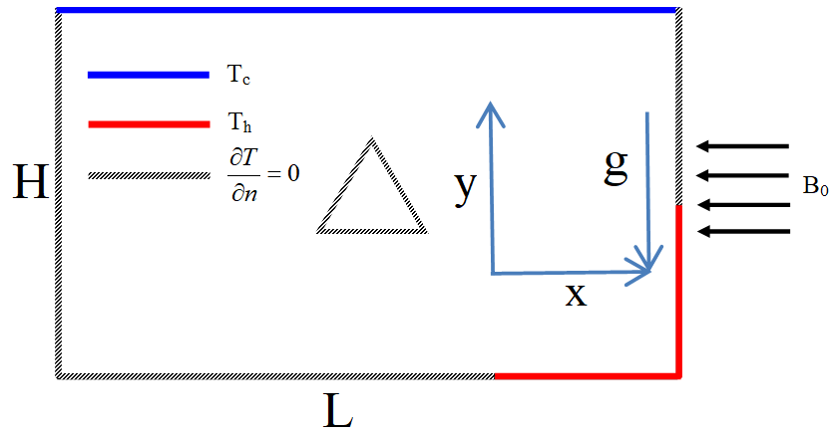

Fig. 1. Schematic of the rectangular cavity in the presence of a triangular.

3. Mathematical Analysis

In this investigation, we examine the steady-state free convection of magnetohydrodynamics within a rectangular cavity characterized by a two-dimensional flow field. The analysis employs the continuity equation, momentum equation, and energy equation for a viscous fluid with constant properties. The governing equations can be expressed as follows:
Continuity equation
$\frac{∂u}{∂x}+\frac{∂v}{∂y}=0$ (1)
Momentum Equations
$u\frac{∂u}{∂x}+v\frac{∂u}{∂y}=-\frac{1}{ρ}\frac{∂p}{∂x}+ν(\frac{∂^{2}u}{∂x^{2}}+\frac{∂^{2}u}{∂y^{2}})$ (2)
$u\frac{∂v}{∂x}+v\frac{∂v}{∂y}=-\frac{1}{ρ}\frac{∂p}{∂y}+ν(\frac{∂^{2}v}{∂x^{2}}+\frac{∂^{2}v}{∂y^{2}})+gβ(T-T_{c})-σB_{0}^{2}V$ (3)
Energy equation
$u\frac{∂T}{∂x}+v\frac{∂T}{∂y}=\frac{k}{ρc_{p}}(\frac{∂^{2}T}{∂x^{2}}+\frac{∂^{2}T}{∂y^{2}})$ (4)

3.1. Boundary conditions

The boundary conditions for the present problem are specified as follows:
At the top wall: $u=v=0,T=T_{c}$ (5)
On the bottom wall: $u=v=0,\frac{∂T}{∂y}=0$ $0≤x≤$0.75L and T=T_{h} , $0.75L≤x≤L$ (6)
On the left wall: $u=v=0,\frac{∂T}{∂x}=0$ (7)
On the right wall:$u=v=0,\frac{∂T}{∂x}=0,0.25H<y≤HandT=T_{h},0≤y≤0.25H$ (8)
On the triangle: $u=v=0,\frac{∂T}{∂n}=0$ (9)

3.2. Non-dimensional variables

The non-dimensionless dependent and independent variables are:
$X=\frac{x}{L},$ $Y=\frac{y}{L},$ $U=\frac{uL}{α},$ $V=\frac{vL}{α},$ $P=\frac{pL}{ρα^{2}},$ $θ=\frac{T-T_{c}}{T_{h}-T_{c}},$ $α=\frac{k}{ρc_{p}},$ $\operatorname{Pr}{=}\frac{v}{α},$
$Ra=\frac{B(T_{h}-T_{c})H^{3}}{αν}$ and $Ha=\sqrt{\frac{αB_{0}^{2}L^{2}}{μ}}$

3.3. Non-dimensional governing equations

From equations (1-4), we get the non-dimensional governing equations:
Continuity equation, $\frac{∂U}{∂X}+\frac{∂V}{∂Y}=0$ (10)
Momentum Equations,
$U\frac{∂U}{∂X}+V\frac{∂U}{∂Y}=-\frac{∂P}{∂X}+(\frac{∂^{2}U}{∂X^{2}}+\frac{∂^{2}U}{∂Y^{2}})$ (11)
$U\frac{∂V}{∂X}+V\frac{∂V}{∂Y}=-\frac{∂P}{∂Y}+\left(\frac{∂^{2}V}{∂X^{2}}+\frac{∂^{2}V}{∂Y^{2}}\right)+RaPrθ-Ha^{2}PrV$ (12)
Energy Equations,
$U\frac{∂θ}{∂X}+V\frac{∂θ}{∂Y}=(\frac{∂^{2}θ}{∂X^{2}}+\frac{∂^{2}θ}{∂Y^{2}})$ (13)
In the above equations, $Ra$ is the Rayleigh number and $Ra=\frac{B(T_{h}-T_{c})H^{3}}{αv}$

3.4. Non-dimensional boundary conditions

The non-dimensional boundary conditions considerations are :
At the top wall: $U=V=0,θ=0$ (14)
On the bottom wall: $U=V=0,\frac{∂θ}{∂Y}=0,$ $0≤X≤0.75L$and $θ=1,_{}0.75L≤X≤L$ (15)
On the left wall: $U=V=0,\frac{∂θ}{∂X}=0,$ (16)
On the right wall: $U=V=0,\frac{∂θ}{∂X}=0,0≤Y≤0.25H$and $θ=1,0.25H<Y≤H$ (17)
On the triangle: $U=V=0,\frac{∂θ}{∂N}=0$ (18)
The average Nusselt number at the heated wall of the cavity based on the dimensionless quantities may be expressed as $Nu=-\frac{1}{L_{T}}\int_{0}^{L_{T}}{\frac{∂θ}{∂x}dY}$ (19)
and the average temperature of the fluid in the cavity is defined as $θ_{av}=\int{θd\overline{V}}$ (20)

4. Grid Test

To determine the suitable grid size, a grid refinement experiment was conducted for the simulation of natural convection within a rectangular enclosure, with specified values for Rayleigh number $Ra= {10}^{4},$ Hartmann number $Ha=20,$ and Prandtl number $Pr=0.70,$ employing a triangular mesh generation approach for the two-dimensional simulation, six distinct meshes were employed, as outlined in Table 1. The investigation revealed that the solution remained unaffected by variations in grid size, with nodes numbering 15426 and elements totaling 29933. The mesh configuration for this numerical analysis is depicted in Fig. 2.

Table 1. Grid test at Pr = 0.70 Ra = 1e4 and Ha = 20.

Nodes | 1056 | 1519 | 2375 | 6192 | 15426 | 22761
Elements | 1971 | 2861 | 4529 | 11909 | 29933 | 44603
$${Nu}_{av}$$ | 1.98569 | 2.01176 | 2.03398 | 2.11204 | 2.16588 | 2.16652

4.1. Mesh generation

Mesh generation involves creating a grid that discretizes a continuous geometric space into discrete cells, serving as approximations for the larger domain. Achieving consensus on the grid’s structure is crucial for accurate representation in computational fluid dynamics. The process of determining such a grid is known as grid generation and is a critical aspect of the finite element method, particularly on unstructured grids. In this method, equations are expressed in fundamental form, allowing for straightforward numerical integration on unstructured grid domains without requiring coordinate transformations. Fig. 2 illustrates the discretization of a two-dimensional area in the finite element method, where mesh generation entails dividing the domain into finite elements. For further details, refer to the accompanying Fig. 2.
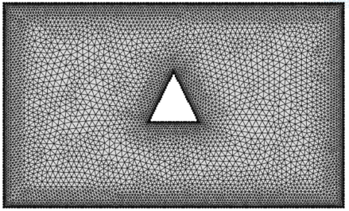

Fig. 2. Current mesh structure for a rectangular cavity with the attendance of a triangular obstacle.

4.2. Code validation

The current numerical code has undergone validation through comparison with a documented numerical investigation. Specifically, our study focuses on the impact of a magnetic field on natural convection, and we have cross-referenced our numerical results with those obtained by Pirmohammadi et al. [23] in table 2. The comparison reveals a notable consistency between our findings and theirs, affirming the accuracy of our numerical simulations for the present problem. Furthermore, we have aligned our numerical outcomes with the research conducted by Jani et al. [24], as depicted in Figs. 3 and 4.

Table 2. Comparison between Pirmohammadi et al. [23] and current study for average Nusselt number ($Nu_{av}$), Rayleigh and Hartmann number at $Ra= {10}^{4}, {10}^{5};Ha=0, 10, 50, 100.$

 | Ha | Pirmohammadi et al. [23] | Current study | Error (%)
Ra = 10⁴ | 0 | 2.29 | 2.25 | 1.77
 | 10 | 1.97 | 1.93 | 2.07
 | 50 | 1.06 | 1.04 | 1.92
 | 100 | 1.02 | 1.01 | 0.99
Ra = 10⁵ | 0 | 4.62 | 4.53 | 1.98
 | 25 | 3.51 | 3.44 | 2.03
 | 100 | 1.37 | 1.24 | 10.48
 | 200 | 1.16 | 1.03 | 12.62

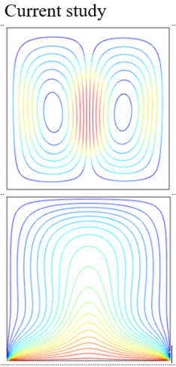
4.3. Program validation:
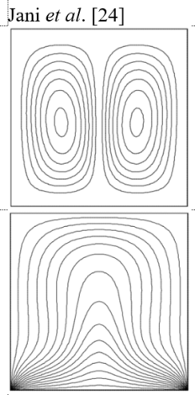

Fig. 3. Comparison between streamlines (top) and isotherms (bottom) for graphical solution of Jani et al. [24] and current study at Pr =0.7, Ra=1e4, Ha = 0.
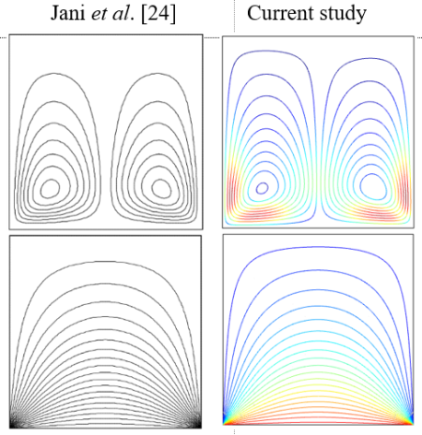

Fig. 4. Comparison between streamlines (top) and isotherms (bottom) for graphical solution of Jani et al. [24] and current study at Pt = 0.70, Ra=1e4, Ha = 50.
5. Results and Discussion

In this segment, graphical representations are provided for the numerical outcomes concerning the impact of the magnetic field on the natural convection flow within a rectangular cavity containing a triangular obstacle. The analysis focuses on the variations of three key parameters: Rayleigh number $Ra,$ Hartmann number $Ha,$ and Prandtl number $Pr.$ Further elaboration and discussion on these findings are presented in the subsequent sections.

5.1. Effect of Rayleigh number (Ra)
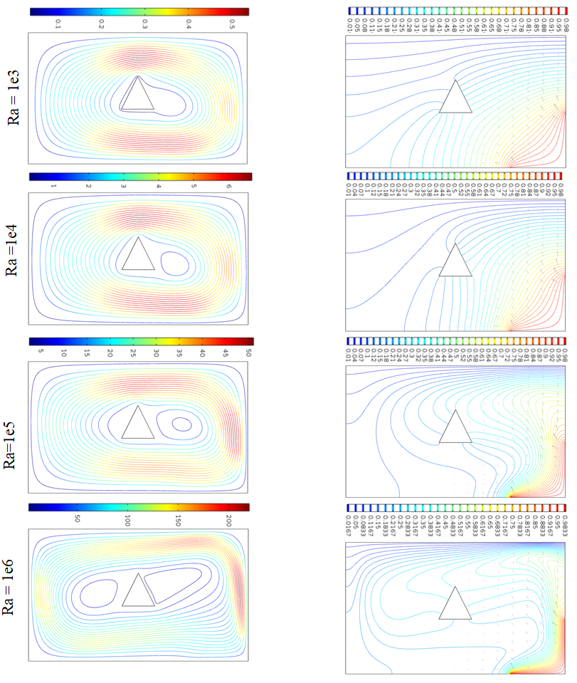

Fig. 5. (a) streamline and (b) isotherms distribution for several Ra at Pr = 0.70 and Ha=20.

The influence of the Rayleigh number on both flow and temperature fields is depicted in Fig. 5. Streamlines are shown for four distinct Rayleigh number values (1e3, 1e4, 1e5, 1e6), with the color indicating the velocity of the flow-blue for lower velocity and red for higher velocity. Initially, for a specific Rayleigh number, the streamlines encompass the entire cavity. As the Rayleigh number increases, a small vortex near the triangular obstacle becomes evident, and the size and strength of the rotating cell are impacted. Furthermore, at higher Rayleigh numbers, double vortices are observed beside the triangular shape.
Fig. 5(b) illustrates the impact of Rayleigh number on isotherms distributions. Isotherms are displayed for the same four Rayleigh number values, with colors representing thermal intensity: blue for lower heat and red for higher heat. Analysis of Fig. 5(a) reveals that isotherms are more heated near the right bottom corner walls of the cavity. Additionally, it is observed that the thermal level adjacent to the heated wall becomes more substantial with an increase in the Rayleigh number. Moreover, at higher Rayleigh numbers, marked variations in isotherms are evident, primarily due to the influence of the heat source on the respective region.

5.2. Effect of Hartmann number
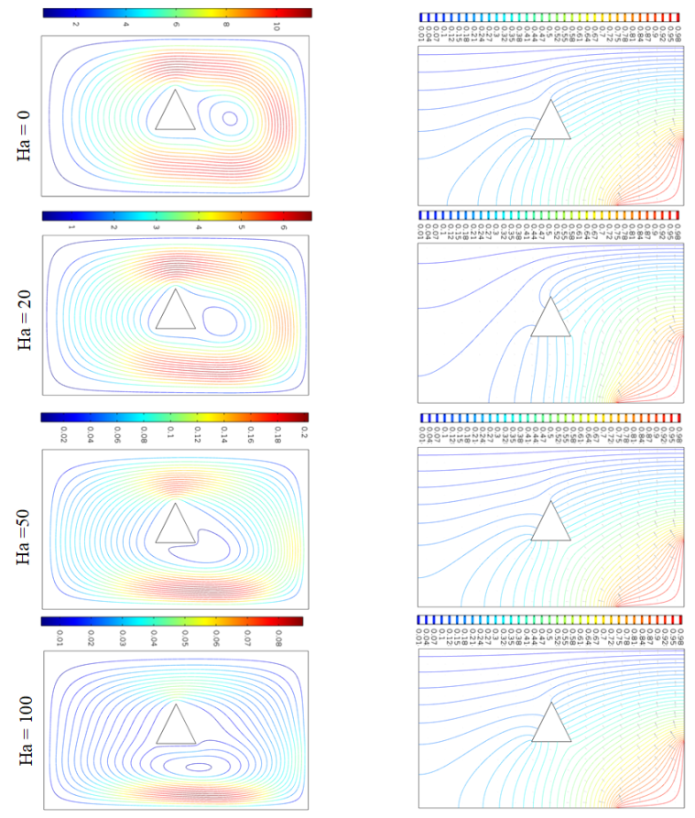

Fig. 6. (a) Streamline and (b) isotherms distribution for various Ha at Pr = 0.70 and Ra=1e4.
Fig. 6 depicts the impact of the Hartmann number on both the flow and thermal fields. Streamlines are shown for four different Hartmann number values (0, 20, 50, and 100), with the color indicating the velocity of the flow (blue for lower velocity, red for higher velocity). When $Ha$ is 0, the streamlines encompass the entire cavity, with a small vortex near the triangular obstacle. As $Ha$ increases, the size and strength of the rotating cell decrease, and double vortices appear near the triangular shape. Notably, fluid velocity significantly decreases with higher $Ha$ values.
The right column of Fig. 6 illustrates the effects of the Hartmann number on temperature distributions, with isotherms presented for $Ha$ values of 0, 20, 50, and 100. The color of the isotherms represents temperature (blue for lower, red for higher). The figure reveals that isotherms are warmer near the bottom right corner of the cavity. The thermal layer near the heated wall becomes thicker and decreases in value as $Ha$ increases. Additionally, there is a minor variation in isotherms for different Hartmann numbers.
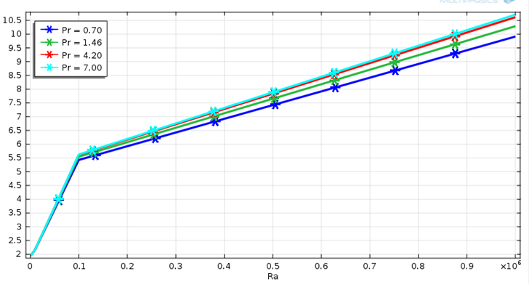

Fig. 7. Average Nusselt number for different Ra and Pr.
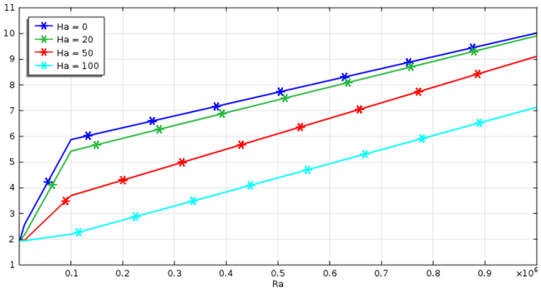

Fig. 8. Average Nusselt number for different Ra and Ha.

In Fig. 7, variations in the Average Nusselt number ${Nu}_{av}$ are depicted concerning different Prandtl numbers $Pr$ and Rayleigh numbers $Ra.$ The graph illustrates that the heat transfer rate rises with increasing Rayleigh number. Notably, at Prandtl number $Pr=0.7$, the ${Nu}_{av}$ is lower, but it progressively increases with higher Prandtl numbers. The maximum ${Nu}_{av}$ occurs at $\operatorname{Pr}{=7.00}$. Conversely, in Fig. 8, the alteration of ${Nu}_{av}$ for different $Ra$ and Hartmann numbers, $Ha$ is presented. When $Ha=0,$ ${Nu}_{av}$ is higher, but it decreases as $Ha$ increases. The graph indicates that at $Ha=100,$ the minimum. ${Nu}_{av}$ is observed.

6. Conclusion

In this current investigation, we have explored the numerical analysis of magnetohydrodynamic free convection within a rectangular cavity featuring a corner heater temperature. The study employs the Finite Element Method, supplemented by the expansion of the Galerkin weighted residual finite element method. The obtained results are presented for a selected fluid with a Prandtl number $Pr$ of 0.70, various Rayleigh numbers $Ra,$ and different Hartmann numbers $(Ha)$ (0, 20, 50, 100). The findings lead to the following conclusion: The Prandtl number $(Pr)$ significantly influences the streamlines and isotherms at the given $Ra$ value. Increasing the Rayleigh number results in elevated cavity temperatures. The heat transfer characteristics within the cavity are notably dependent on both the Rayleigh and Hartmann numbers. Higher Hartmann numbers lead to lower cavity temperatures, while increased $Ra$values result in higher temperatures. The temperature distribution parameter is mainly influenced by the $Ra$ and $Ha$ values at the corner of the cavity. Furthermore, the average Nusselt numbers are found to be dependent on $Ra,$ with an increase in $Ra$ leading to an augmented average Nusselt number, as depicted in Fig. 7. The average Nuselt number experiences a decrease with an increase in Hartmann number $(Ha)$, as shown in Fig. 8. Conversely, a decrease in $Ha$ results in an increased average Nusselt number.

Nomenclature
d Dimension cylinder length (m)
D Non dimensional cylinder length
G Gravitational acceleration ($s^{-2}$)
k Thermal conductivity of fluid ( 𝑊𝑚−1𝑘 −1 )
L length of the cavity ( m )
Nu Nusselt number
p Dimensional pressure ( 𝑁𝑚−2 )
P Dimensionless pressure
Pr Prandtl number
Re Reynolds number
Ri Richardson number
Ha Hartmann number
Gr Grashof number
T Dimensional temperature ( K )
u, v Dimensional velocity components ( 𝑚𝑠 −1 )
U, V Dimensionless velocity components
𝑉 Cavity volume ( 3 )
w Height of the opening ( m )
x, y Cartesian coordinates ( m )
X, Y Dimensionless Cartesian coordinates
𝑄° volumetric heat generation or absorption coefficient
Q Dimensionless Volumetric heat generation or absorption parameter
𝑐𝑝 Specific heat capacity ( J𝑘𝑔 −1 𝐾 −1 )
n dimensional distances either x or y direction acting normal to the surface
N Non dimensional distances either X or Y direction acting normal to the surface
𝐵° magnetic induction ( $m^{-2}$ )

Greek Symbols:
𝛼 Thermal diffusivity ( 2 𝑠 −1 )
𝛽 Thermal expansion coefficient ($k^{-1}$ )
𝜌 Density of the fluid ( $m^{-3}$ )
𝜃 Non dimensional temperature
𝜐 Kinematic viscosity of the fluid ( 2 𝑠 −1 )
𝜎 Fluid electrical conductivity
𝜇 Dynamic viscosity of the fluid
𝜓 Stream function

Reference

- K. Hussein, S. K. Rout, F. Fathinia, R. Chand, and H. A. Mohammed, J. Eng. Sci. Technol. 10, 1326 (2015).
- M. K. Kane, C. Mbow, M. L. Sow, and J. Sarr, Open J. Fluid Dynamics 7, 623 (2017). https://doi.org/10.4236/ojfd.2017.74041
- S. A. Hosain, M. A. Alim, and S. K. Saha, MHD Natural Convection in Open Inclined Square Cavity with a Heated Circular Cylinder - AIP Conference Proc. (AIP Publishing LLC, 2017), 1851(1) pp. 020051. https://doi.org/10.1063/1.4984680
- M. J. H. Munshi and M. A. Alim, J. Sci. Res. 9, 1 (2016). https://doi.org/10.3329/jsr.v1i1.27702
- F. Selimefendigil, Y. Akbulut, A. Sengur, and H. F. Oztop, J. Thermal Anal. Calorimet. 140, 1468 (2019). https://doi.org/10.1007/s10973-019-08865-7
- A. H. Bhuiyan, S. F. Ferdousi, and M. A. Alim, Int. Res. J. 14, 2249 (2014).
- M. A. Alim, A. Farhana, and M. N. Uddin, Finite Element Analysis of Magnetohydrodynamic (MHD) Mixed Convection Flow on a Triangular Cavity – Int. Conf. on Mechanical Engineering, FL-039 (2011).
- M. J. H. Munshi, M. A. Alim, M. Ali, and M. S. Alam, J. Sci. Res. 9, 145 (2017). https://doi.org/10.3329/jsr.v9i2.29644
- M. J. H. Munshi, G. M. Mostafa, A. B. S. M. Munsi, and M. Waliullah, Am. J. Comput. Math. 8, 245 (2018). https://doi.org/10.4236/ajcm.2018.83020
- O. Turk and M. Tezer-Sezgin, Int. J. Numer. Method Heat Fluid Flow 23, 844 (2013). https://doi.org/10.1108/HFF-12-2010-0196
- M. M. Islam, M. A. Alim, M. M. Alam, and M. J. H. Munshi, J. Appl. Sci. 13, 591 (2023). https://doi.org/10.4236/ojapps.2023.134047
- R. Chowdhury, S. Parvin, and M. A. H. Khan, An Int. J. Special Topic Porous Media 6, 353 (2015). https://doi.org/10.1615/SpecialTopicsRevPorousMedia.v6.i4.40
- M. A. H. Khan, R. Chowdhury, and N.-A-A. Siddiki, Am. J. Appl. Math. 3, 51 (2015). https://doi.org/10.11648/j.ajam.20150302.14
- M. A. Alim, M. S. H. Mollah, and M. S. Alam, Int. J. Theor. Appl. Math. 5, 44 (2019). https://doi.org/10.11648/j.ijtam.20190503.12
- S. P. K. Sarker, M. M. Alam, and M. J. H. Munshi, Int. J. Fluid Mechan. Thermal Sci. 9, 20 (2023). https://doi.org/10.11648/j.ijfmts.20230902.11
- S. P. K. Sarker, M. M. Alam, and M. J. H. Munshi, J. Appl. Math. Phys. 11, 3984 (2023). https://doi.org/10.4236/jamp.2023.1112255
- T. Basak and A. J. Chamkha, Int. J. Heat Mass Transfer 55, 5526 (2012). https://doi.org/10.1016/j.ijheatmasstransfer.2012.05.025
- M. Fayz-Al-Asad, M. M. A. Sarker, and M. J. H. Munshi, J. Sci. Res. 11, 173 (2019). https://doi.org/10.3329/jsr.v11i2.38797
- M. M. Ali, M. A. Alim, M. A. Maleque, and S. S. Ahmed, Am. Institute Phys. 1851, ID 020055-1 (2017).
- M. Obayedullah and M. M. K. Chowdhury, Procedia Eng. 56, 76 (2013). https://doi.org/10.1016/j.proeng.2013.03.091
- M. A. Alim and M. M. Rahman, Nonlinear Analysis: Model. Control 15, 199 (2010). https://doi.org/10.15388/NA.2010.15.2.14354
- S. Hussain, H. F. Öztop, K. Mehmood, and N. Abu-Hamden, Chinese J. Phys. 56, 484 (2018). https://doi.org/10.1016/j.cjph.2018.02.002
- M. Pirmohammadi, M. Ghussemi, and G. A. Sheikhazadeh, IEEE Trans: Magn. 45, 401 (2009). https://doi.org/10.1109/TMAG.2008.2008685
- S. Jani, Mahmoodi, M. Mahmoodi, and M. Amini, Int. J. Mech. Indust. Sci. Eng. 7 (2013).
- R. Akhter, M. M. Ali, and M. A. Alim, Alexandria Eng. J. 62, 17 (2023). https://doi.org/10.1016/j.aej.2022.07.005
- M. M. Ali, M. A. Alim, R. Akhter, and S. S. Ahmed, Int. J. Appl. Comput. Math. 3, 1047 (2017). https://doi.org/10.1007/s40819-017-0400-y

∗ Corresponding author: drmunshi@hamdarduniversity.edu.bd

